***Foxy Loxy***

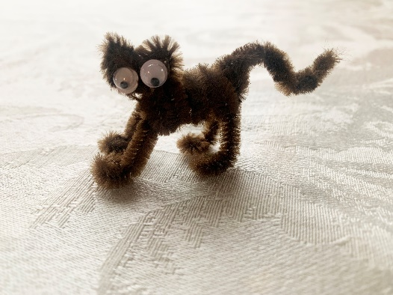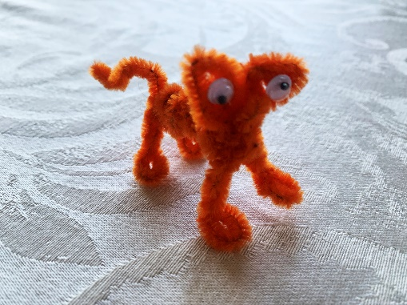

Foxy Loxy is my first attempt at creating a pipe cleaner animal. Foxy was inspired by the fox that lived under our back deck one summer. When I needed to create something out of an orange pipe cleaner for an Instructional Design class, Foxy Loxy was born. Your foxy, may be orange or brown or whatever color you like if you have your own pipe cleaners to play with.

Shortly after Foxy was born my husband and I discovered geocaching, searching for hidden treasures. Most of our treasures are on the hiking trails in Colorado, so far at least. As we discovered one of the larger cache containers it occurred to me that it might be fun for folks discovering the container behind us to find a little bit of fun inside. If you stumbled into this world by accident, check out [www.geocaching.com](http://www.geocaching.com). You may just find yourself hooked!

If you found the Cache Critter Kit then you should have everything you need, check your supplies against the list below, or gather up what you need. Follow the instructions below or refer to the video at <https://studio88design.online/critter_cache_kits/> and follow along there.

*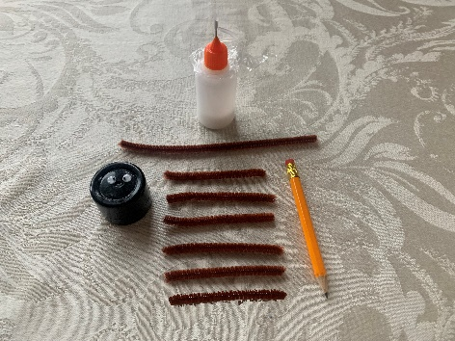***Supplies:**

2 Pipe Cleaners

* 1 pipe cleaner cut in half, then cut half in half again
* 1 Pipe cleaner cut in half, set one aside, cut the other half in 2

*You should have six short pieces and 1 long piece.*

2 Eyes

Pencil for wrapping long pipe cleaner around

A touch of glue

**Instructions:**

1. 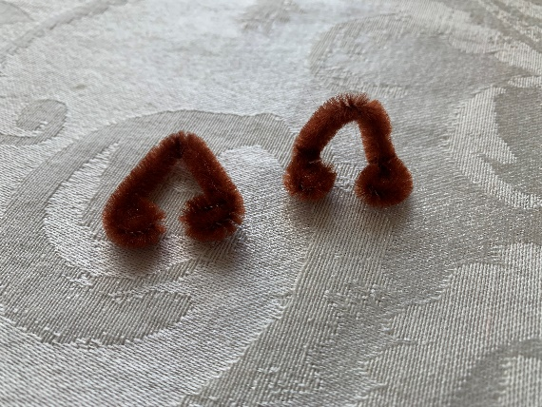Fold 2 of the shorter pieces (1/4 pipe cleaner) in half, these will be the legs/feet.
2. Twist each of the four ends twice to form a tight circle for the feet.
3. Bend each circle/foot 90 degrees so the legs stand on their own.
4. Bend the 3rd short piece in half, we will call this the underbody.

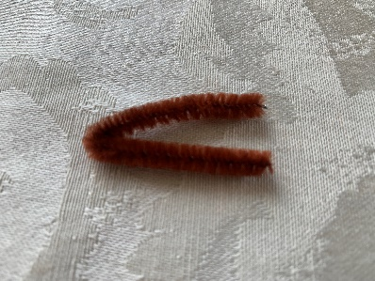

1. Slide one of the sets of legs between the 2 pieces of the underbody to the bend, be sure the feet are facing forward. Twist the short piece 1x tight against the legs to secure.

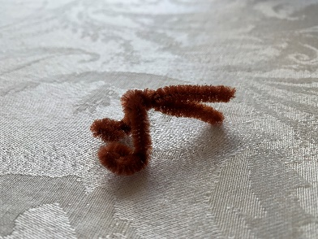

1. Loosely twist 2 more times to get to the end of the pipe cleaner. Leave the very end apart so you can secure the back feet.
2. Using the long piece (1/2 pipe cleaner) twist it tightly around the pencil to create a loose spiral, this will be the body.
3. Slide the spiral onto the underbody and up against the front legs.

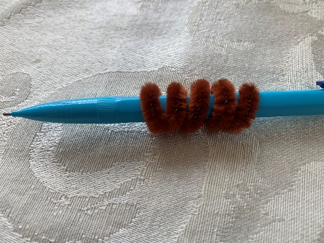 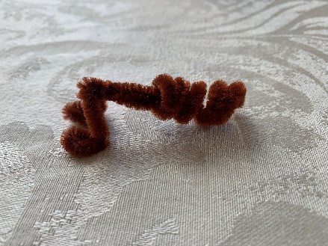

1. 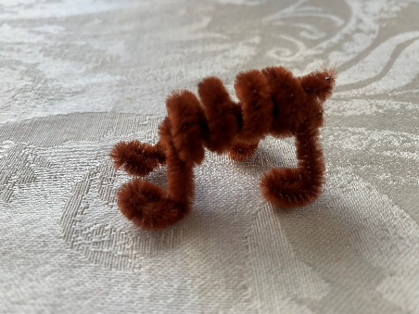Slide the other set of legs onto the back of the underbody up against the spiral. Twist the open ends of the underbody to secure. Your fox should be able to stand on his four feet now.
2. Using the 4th short piece make a tight circle and continue to wrap the circle until you have no more pipe cleaner, this will become the head.
3. Hold the end in your finger and press down on the other side to make a heart shape, this forms the ears. Pinch each ear to a point.

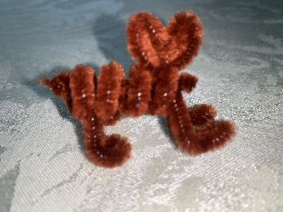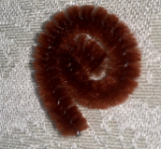 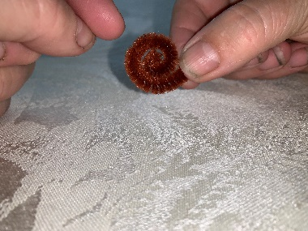 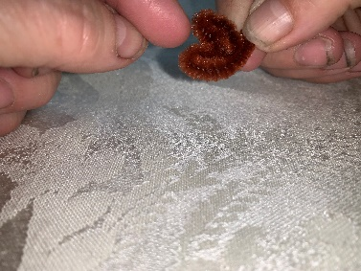

1. Slide the end through the top of the spiral where the front legs are. Twist to secure. Don’t worry if his head isn’t in the right position yet, we can fix that later.
2. The 5th and 6th short pieces will be the tail. Twist them together lightly. The looser they are the more fluffy the tail will look.
3. Bend the tail in half and slide it onto the back of the body spiral by the back feet.
4. Twist 1x tightly close to the body and loosely to the end of the tail.
5. I like to bend the tail down, then back up again, you can position however you like.

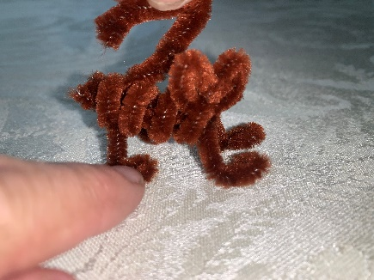 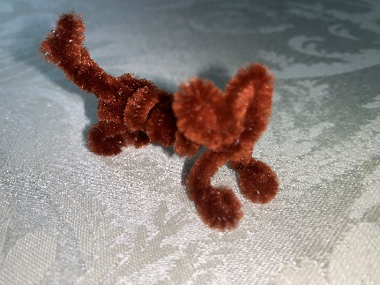

1. Glue the eyes on and once they have dried, twist the head into the position you want it to be in.

**Happy Caching!** *Stoosh1 c/o Shawna’s Studio88*