**Zoom for Moderators**

There is a lot of information below, be sure to review and ensure you know your role if you are co-moderating with another person! Hosts & Co-hosts are covered first, information following is based on icon order from left to right. Breakout rooms are at the end of the document.

Host & Co-Hosts Icons

Co-hosts can be assigned by the person that sets up the initial meeting, the host can also assign co-hosts once the meeting starts. To add a cohost before the meeting you will need to edit the meeting and add the co-host’s [“identikey”@colorado.edu](mailto:) email address at the bottom of the edit screen.

* Only the HOST can set up breakout rooms
* Both hosts and co-hosts can assign another person to be co-host
* If you are the original host and you assign someone else that role you lose the role. You may want to ask the new host to make you a co-host
* The first person (host or co-host) to join the meeting becomes the host, even if they were assigned a co-host role. If this is the case the host becomes a co-host when they join
  + This is important for sessions with breakout rooms since the HOST is the only one who can set them up and run them. We want the moderators to run the breakout rooms so the trainer can focus on presenting. If you are moderating a session with breakout rooms be sure to review the information in the breakout rooms section below so you are ready to assign and launch the rooms.

Hosts and co-hosts have most of the icons listed below. The breakroom icon will only show up on the Host’s screen if breakrooms were designated as part of the meeting set-up. **Only the HOST can see the Break Out room icon.**  If breakout rooms will be used during the presentation the person who will be launching them, closing them out, and troubleshooting should be assigned as the host. The host can also move between breakout rooms as they wish, however it is best if they stay in the main room and move other moderators (co-hosts) if needed. This allows them to remain in the main room and watch for messages from rooms who need assistance.



There is a line through the microphone and camera if they are not enabled. You will want to monitor cameras and microphones in the participant window during the presentation. You can mute participants who activate their microphone to speak and forget to turn it off, this will help with feedback in large groups or for people who have background noise and are not speaking. This training is highly participatory, discussion based training. All cameras should be on.

The small arrow beside these two icons allows you to change your settings if you have more than one camera or microphone to choose from.

**The security icon**

This icon effects all participants. From here you can designate the following

* Enable the waiting room if needed
* Allow participants to
  + Share screen
  + Chat
  + Rename Themselves - *if the participant has their initials as a name it might be helpful to ask them to rename themselves. They can do this through the participant icon, hovering over their name, use the more button to choose rename*
* Remove participant

**Participant Icon**

This shows all participants in the meeting and their role if they have one as well as control many aspects of the meeting. To see options from each participant hover over their name to see the *mute/unmute* and the *More* options

* You can see if cameras and microphones are activated and as a host or co-host you can mute people from this screen as well.
* The *More* option is where you designate someone as co-host or host as well as an interpreter or closed captioner if those options have been preset. **If you make someone else the host you become a participant and no longer have the ability to change people’s rolls or assist with meeting controls. If they need to be host to control breakout rooms you may want to ask them to make you a co-host.**

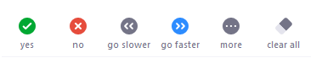Participant’s “participant” icons

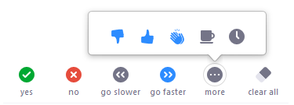

------------------------------------------------------------------------------------------------------------------------------------------

Moderator’s “participant” icons

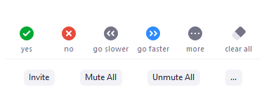

* Mute on Entry
* Allow participants to unmute
* More
  + Turn on/off chime upon entry

------------------------------------------------------------------------------------------------------------------------------------------

Polls

Polls can be added prior to the meeting by editing the options in the setup screen. To add polls you must be either a host or a co-host, log into your Zoom profile, locate the meeting, click edit, then scroll to the bottom to add polls.

Polls can also be added on the fly during the meeting but this is much more difficult to do smoothly while presenting or moderating!

* If you have more than one poll you will see a drop-down arrow to select the poll you wish to launch
* Click the button to launch the poll, as responses come in you will see how many have responded as well as the % of participants responding and the current status of which answer is being selected most often.
* End the poll
* You can choose to share the poll results so all participants can see the results
* You will need to close the poll window to remove it from the screen

Chat

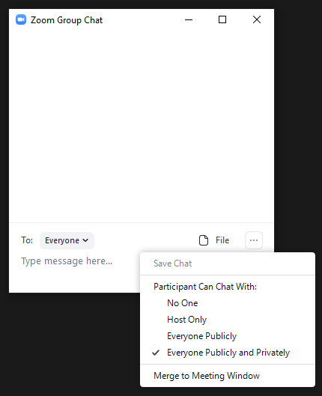Using chat is the same for everyone, however the meeting presenter may choose to disable chat for participants if they want their full attention to be on what they are presenting. Hosts and co-hosts will always have the ability to chat amongst themselves.

* Use the *more* option (…) to adjust who can chat with whom
* The *Save Chat* will activate once at least one chat has been sent
* 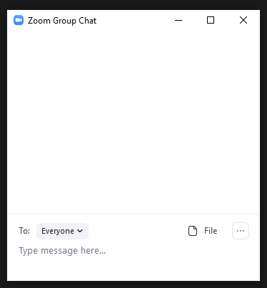Notice the drop down by the **To** field. This is where you choose to send a message to everyone or to chat privately with someone
* If you need to share a website or a Google document it is easiest to have it saved to a Word document on another screen where you can copy it quickly and quickly paste it into the chat box when it’s time. Once you paste it people will be able to click it and link to the document
  + If they are not able to link to a Google document it is likely that the person who created the document did not assign the proper sharing permissions to allow everyone with a link to view the document.

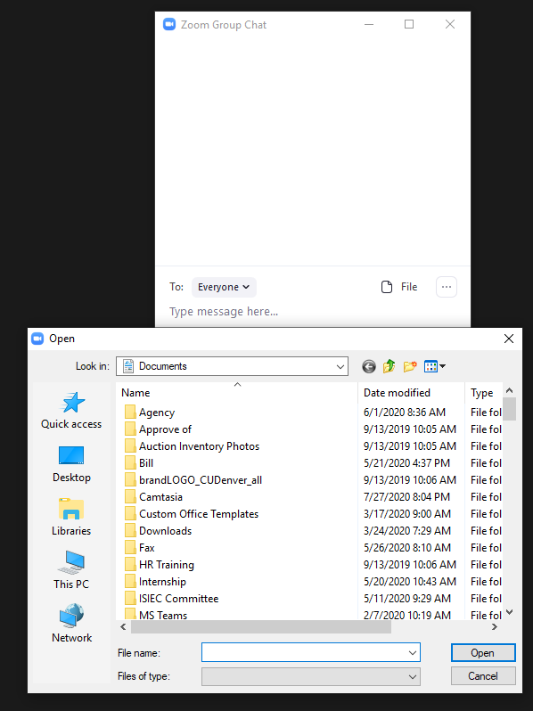You can also share a file with the participants by placing it in the chat box.

* Click the *file* icon, then search on your computer for the file you wish to share, select it, and choose open
* 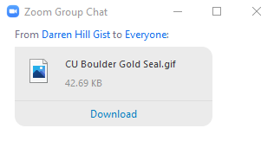The participants will see a visual that advises them a file is available. If they click the *download* button they can save the file to their computer. Once saved they can choose to open it from the chat or access it on their computer later.

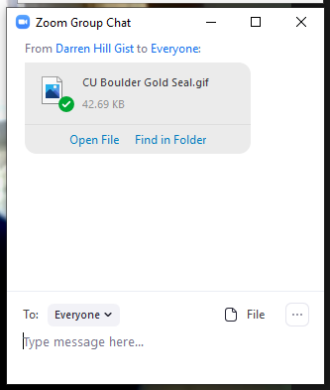

**Reactions**

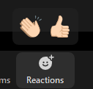This icon gives everyone the option to use an icon to applaud or give a thumbs up. These icons show up on their video screen. If you are asking people to raise a hand to participate verbally be sure you can see the Zoom screen with the participants to see their hands or reactions!



**Share Screen**

This is the green box icon with the up arrow located in the middle of the control panel. Once you click this you will see a pop-up that asks you which screen you wish to share. Every window you have open on your desktop will be available to share. Here are some hints

* Share your **SCREEN** if you need to move between applications, websites, etc. while participants are viewing your screen.
* Share a single screen if you just need them to see a single screen that you have launched already
* You can bring up a document on your second monitor and have it ready to screen share either by sharing that document or the screen it is on
* If you are sharing something that has audio be sure to share click the two buttons on the bottom of the pop-up when you are selecting what to share **and before** you actually launch the screenshare
* Look for the thin green/red screenshare bar to locate the “stop sharing” box

To request control from the presenter click View options drop down.



**White Board**

You can preset content on the white board in the main meeting room by launching the meeting early, use the screenshare option to launch the white board, add your content to the white board, then stop sharing. **Do not close out the meeting or you will lose your white board**. You can also have more then one white board during a meeting and preset content on the white board.

**Annotating on a White Board**

**Moderator View**

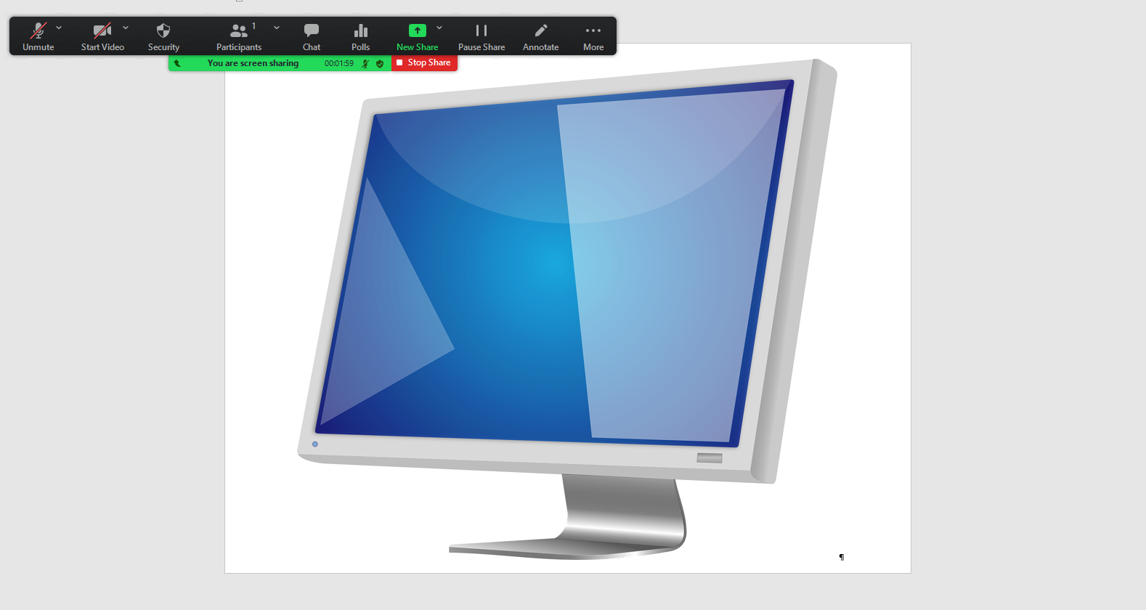

* Annotate whows in the black tool bar, click it to see annotation options
  + A secondary tool bar shows up with the ability to write, type, use stamps (checkmark, x, arrow, heart), erase items on the whiteboard, clear all items. Save the annotation before you exit the room if you want a copy of the board. The red “x” closes the toolbar
* The More button gives some additional options

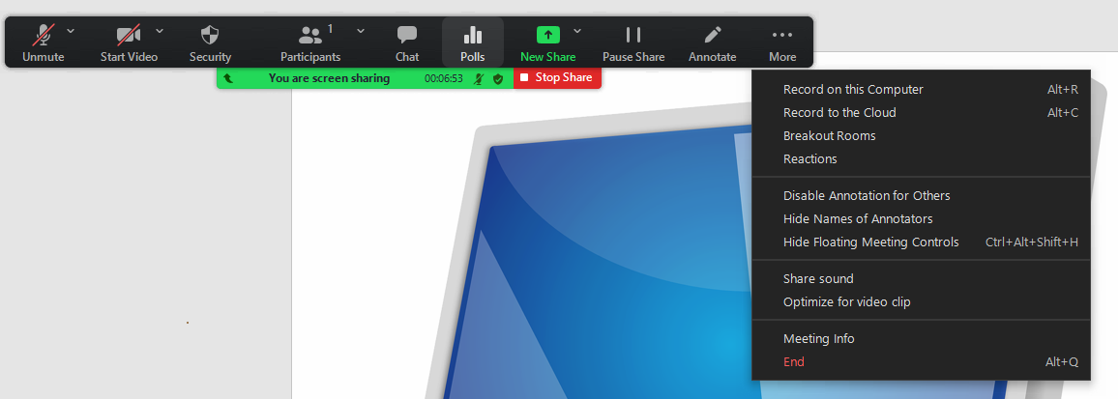

* Notice that you can pause your screenshare and change the screen you are sharing without returning to the room. You’ll need to have the document open on your desktop then use the down arrow beside the *New Share* icon to switch to another screen. This creates a transparent switch for the attendees.

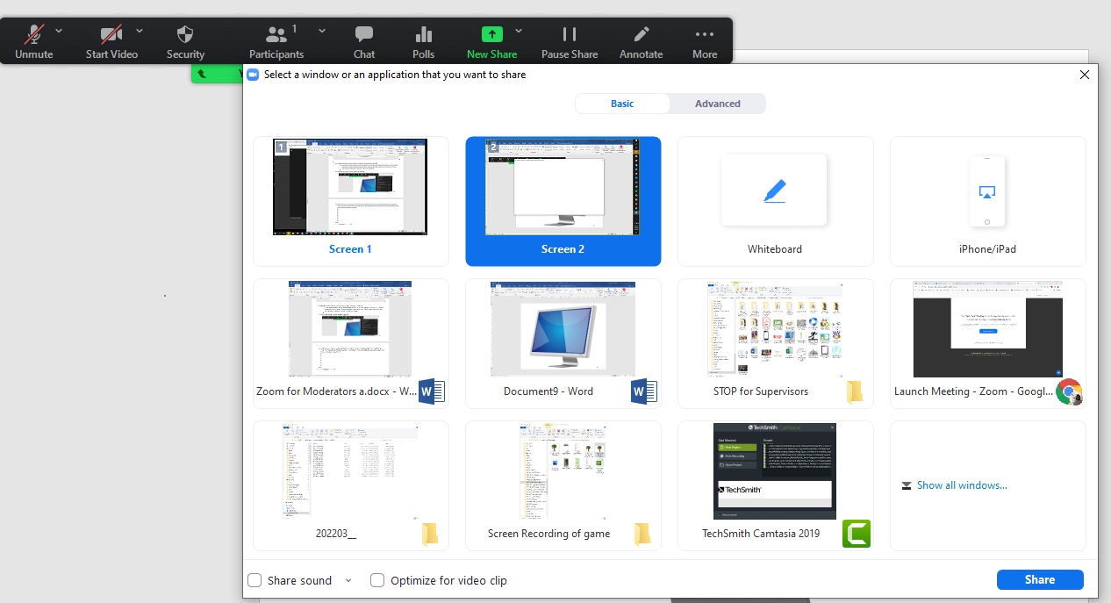

**Saving the White Board**

Use the SAVE icon on the right side of the tool bar to save the whiteboard to the *Documents* folder on your computer’s hard drive. If you are saving more than one white board (for example white boards from each breakout room) you may want to use the Text Tool to add a title to the top of the white board so you know which board is which.

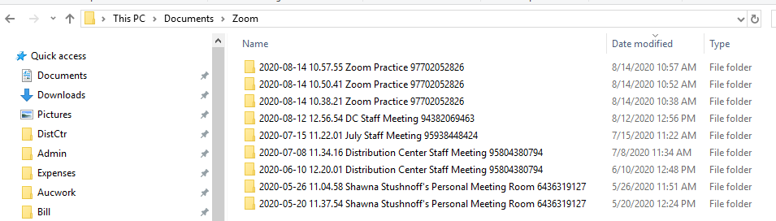

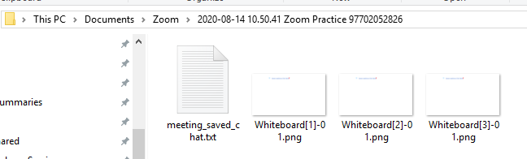

**End Meeting**

Hosts and co-hosts can leave a meeting at any time or end the meeting for all participants. Use the red button in the bottom right of the screen to launch a pop-up that will offer you the choice of leaving or ending the meeting.

**Breakout Rooms**

**Note: When returning from Breakout Rooms Zoom will unmute everyone including the Hosts and Co-Hosts. Watch microphones from the participant screen to mute/unmute mikes as needed.**

**Breakout Rooms**

* Breakout rooms can only be set up and run by the host. If you are the host you should be prepared to run the breakout rooms for Jeff. If there is more than one moderator decide who will be assigned as host to run them.
  + If you are a co-host moderator who signs in first you will automatically be assigned as host, all other presenters and co-hosts will be assigned a co-host role regardless of original set up.
  + The other moderator will be a co-host and should move between breakout rooms to help those in the room with the discussion assignment as needed. Decide who is going where ahead of time…
  + If you assign someone else as host, be sure to ask them to assign you as co-host!
* Breakout rooms can be set up from inside the meeting however you cannot add people to the breakout rooms **until they join the meeting**. To effectively set up the meeting breakout rooms follow the steps below
  + Chat the presenter privately to confirm how long they want the breakout sessions to last. If this is a set amount of time you can designate the duration of the rooms when you set them up which makes your life easier!
  + Agree on which moderator is going to act as host and manage the breakout rooms and which moderator(s) will move between breakout rooms to check-in with the presenter, this person should also monitor chat during the breakout rooms along with the host who may be tied up with other things.
    - Host moderator handling breakout rooms should follow the steps below to set up and launch the breakout rooms.
    - Co-host moderator should
      * Act as part of the welcome committee and greet participants as they join the meeting!
      * Open the chat and participant windows to assist with answering questions, muting microphones when needed, etc.
      * Make sure they are aware which breakout room(s) they are assigned to visit and assist with when the time comes
      * Assist with breakout rooms when they are launched
        + Are they discussing what they should be, do they need a reminder of the question?
        + Launch the white board, write on it for them, and take a screen shot to save their board to YOUR desktop
        + Be prepared to screenshare the whiteboard from the rooms you visited

SETTING UP BREAKOUT ROOMS

* + The host should use the following steps to set up breakout rooms **as soon they join the session**. *You begin this process before the participants arrive so you can log in up to 30 minutes early and begin the process, just don’t leave the meeting between setup and try to rejoin, your breakout rooms will be gone and you’ll have to start over!* *Zoom will log you out after 30 minutes of inactivity so don’t set them up too early!* 
    - 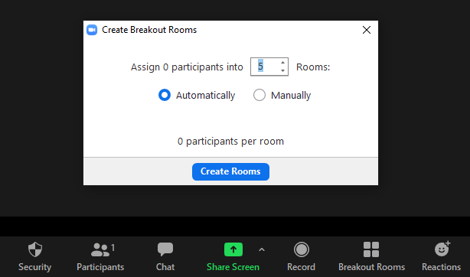Know how many breakout rooms you need add 1 to your total
    - Click the Breakout Rooms icon in the toolbar at the bottom of the Zoom interface
    - Designate the number of rooms you need and click the radio button to assign **manually**!
    - Click the **Create Rooms** button
    - Click the *Options* dropdown at the bottom of the breakout room pop-up
      * If there is a static amount of time for the breakout room check the box and designate the time period you wish them to be open for
      * Click notify me when time is up so you are alerted that everyone is returning.
        + Watch for participants to return and mute their mikes when they do!

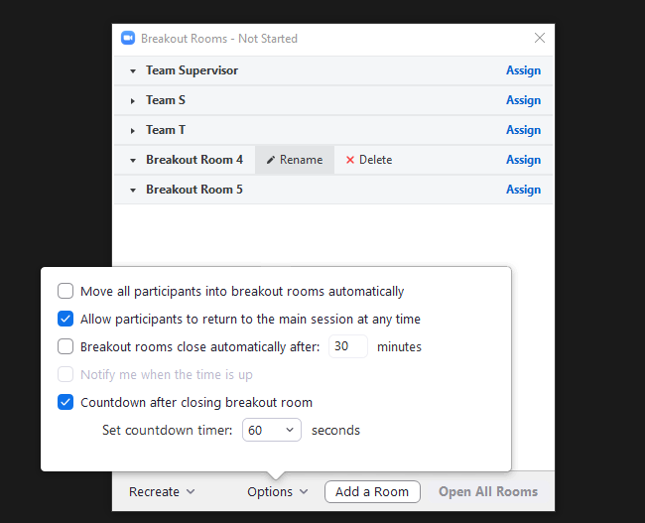

* + - Hover just to the right of the Breakout Room name to reveal the *Rename* option
      * You can rename teams to make it easier to know who is in which room and which moderator/presenter is going to which room
        + For example if you have four teams give them a team name that represents the work STOP, use colors, or whatever you like.

Team S

Team T

Team O

Team P

* + - * + You should have an extra room you have **not**  re-named. This is where everyone gets assigned originally once the session has started.
    - Click the “x” in the upper corner of the pop-up to exit the breakout rooms and leave them intact. **DO NOT END OR LEAVE THE MEETING, IF YOU DO YOUR BREAKOUT ROOMS WILL VANISH AND YOU WILL NEED TO START AGAIN**
    - Once participants begin arriving you can assign them to their breakout room
      * Click the *Breakout Rooms* icon
      * Click the *Assign* option on the right side of the breakout room that doesn’t have a name, assign everyone to this room as they join the meeting.

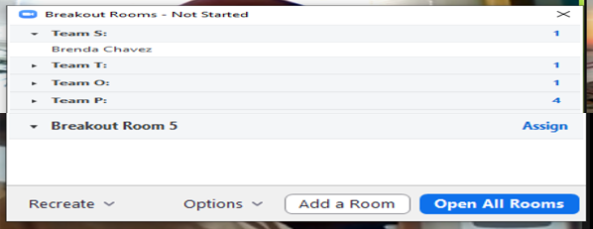

* + - * Return to the un-nammed room and move people to the room you want them in.
      * Select the person you wish to assign to the room
      * Once everyone joined the meeting and been assigned to their correct room hover over the room name for the extra room and delete it, you’re ready to go.

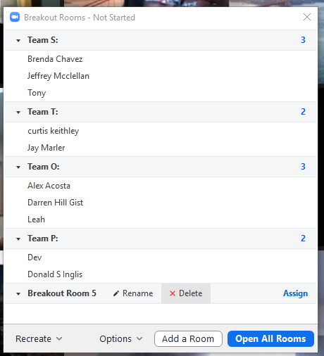

* + - * If you need to move someone to another room hover over their name and chose the *Move To* option

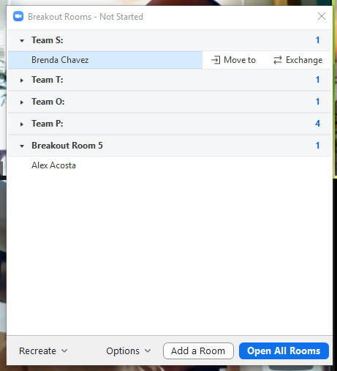

* + - * Select the room you want to send them to

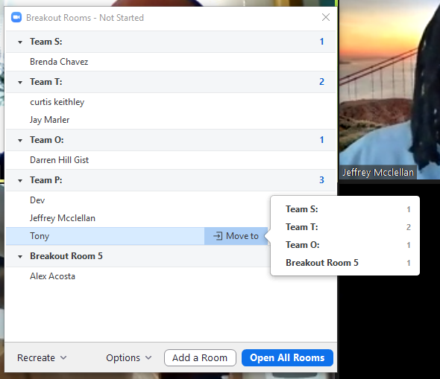

**Note: this is the process you will use to move the presenter and moderators between rooms when they need to switch breakrooms**

* + - You can send a private chat to the presenter and your other moderator to confirm who will visit which room during the breakout session however you’ll be moving them anyway so it is not necessary as long as they know how many rooms they need to visit so they can split their time up. You do not want to assign yourself a breakout room if possible since you need to be in the session to move them and to watch for breakout rooms that send a “help” request.
    - When it is time to open the breakout rooms
      * Click the *Breakout Rooms* icon
      * Advise the participants that they will see a pop-up on their screen advising them they have been assigned to a room and to watch for the pop-up where they will click a button to go to the room, make any other announcements as needed
      * Click the *Open All Rooms* button
      * Watch for everyone to join their rooms
    - During breakout room time
      * Watch the main room until everyone has gotten to their breakout room
      * Send a chat from the main room to all breakout rooms with additional information if needed
      * Verify the questions or discussion topic were placed in the chat
      * Remember you can close the rooms early if needed, they will get a 60 second warning then be returned to the main room.
      * Watch for *help* notices from breakout rooms and trouble shoot as needed

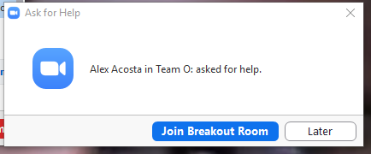

* + - * Move the presenter and moderator from one room to another as needed
      * Watch the chat and the presenter’s mike to ensure it is not muted when they return to the main room.

*Note: Breakout rooms can be set up by the host ahead of time from within the Edit/Options are of the meeting through the profile of the person who created the meeting.*

* + *If breakout rooms are set up through the meeting options they will remain intact until they are changed. This creates a type of static group, although people can be moved from within the meeting as well once they join.*