**STOP MODERATOR NOTES: SESSION 3, Unit 2**

**THE PLAN**

Presenter = Co-host: Jeff

Running Kahoot this week: Shawna

Moderator 1 = Host: Shawna

Breakout Rooms!

**Wheel of Forced Participation**

* + - 1. [https://wheelofnames.com/#](https://wheelofnames.com/)
      2. Logon: [fmcomms@colorado.edu](mailto:fmcomms@colorado.edu)
      3. Password: FMComms#1!
      4. STOP Fall 2021 wheel

Moderator 2 = Co-Host: Michele (Tuesday) Nancy (Wednesday~~)~~

**Whiteboard:** **No**

**Zoom Poll:** **No**

**PREPARE FOR CLASS ABOUT 30 MINUTES PRIOR**

**MODERATOR 1 / HOST:**

* Ask person who scheduled meetings to make you the host, you can change them to co-host
* Click the *Security* icon in the Zoom toolbar and click the *allow rename* option to enable it
* Open Wheel of Forced Participation
* Drop the following text into chat as people join, **remember those who join after you put something in chat don’t see it, you’ll need to add these to chat multiple times**
* Set up three breakout rooms as follows, you can drop people into them later, during the movie
  + 3 rooms
  + Close rooms automatically after 10 minutes
  + Use **options** to
    - **Verify:** allow participants to return to the main session is checked
    - Presenter will visit breakout rooms to answer questions**, *if we uncheck this Jeff can’t leave the room to come back and be assigned to another room!***
    - **Check:** Automatically move all assigned participants into breakout rooms
    - **Change Time:** to close breakout rooms after 10 minutes
    - **Check:** Notify me when time is up
    - **Check:** Countdown after closing breakout room, set to 60 seconds
    - 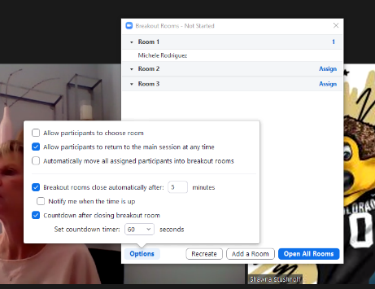DON’T PLAN TO VISIT A ROOM YOURSELF, YOU WILL NEED TO BE AVAILABLE TO MOVE YOUR MODERATORS AND JUMP INTO A ROOM THAT CALLS FOR HELP

**ADDITIONAL MODERATOR(S)**

* Greet people as they arrive
* Open chat and the participant windows, reposition them on one side of your screen
* Verify you are on Grid View
* Watch the participant window, if you see someone with an identikey or something other than their name ask them to rename themselves so we all know who they are
* Verbally remind participants **pop open** their chat so they can see the questions when they get to the breakout room

--------------------------------------------------------------------------------------------------------------------------------------------------------------

**CLASS FLOW**

PRESENTER: Click the recording button to record the class

HOST: Verify class is being recorded, if not chat the presenter **privately** to alert them

1. Screenshare the leaderboard as soon as people begin to arrive

Remind people to launch Kahoot so they are ready to go

Drop the following into chat as people arrive

Class is being recorded!

Don’t for get to launch Kahoot on your second device!

Pop out your chat and move it to your Kahoot screen. This is REALLY important for this class

Review screens and names. If neeeded drop the following into chat as people arrive

Please be sure your camera is on and you are familiar with where to find *chat*. Please review the other tools you see on the screen as well!

Also, check your screen name and rename yourself if your first name is not showing up.

To Rename Yourself: Click the *participant* icon in your Zoom toolbar, hover over your name, click the more button, and select rename

1. Presenter will review the unit 2 focus points and call for participation, have the wheel of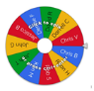 forced participation ready to share and spin
2. Presenter will screenshare this unit’s safety video.

Host/Moderators

* Be ready to turn on your video so you can give a thumbs up when you see the video on screen share and also hear the audio
* Unmute and advise Presenter if something isn’t working

**Host**

* + - Verify breakout rooms are ready

1. Key Concepts
2. Presenter Launches Kahoot

**Kahoot Reminders**

* Remind players it is best to keep Zoom on their computer or one of their computer screens and access the app or Kahoot.it from another device or screen
* Their role is a student
* Moderators review the participant window to make sure the same number of nicknames show up as people in the class

1. Field Activity
   1. Presenter will ask for volunteers to speak about their activity from the past week (examples of Safe/Unsafe PPE)
   2. Two points will be awarded for each volunteer that speaks
   3. Might need to use the wheel
2. **Group Activity / Breakout Rooms**

Prepare to launch breakout rooms, do not put presenter into a room right away

**Injury Investigation**:

Presenter will give a scenario, in breakout rooms participants will come up with questions to ask key people associated with the situation. They will take notes and be prepared to report back to the group.

Presenter will encourage people to make sure chat is popped out and drop the scenario information below into the chat

TEXT TO PASTE TO CHAT

* Copy the information below and paste into chat - **paste as two separate chats!**

Scenario 1

* Welder complains of breathing problems, ordered own respirator, wheezing on and off during day, filed incident report.
* INTERVIEW: Welder, FM Safety, EHS, Supervisor, Manager

Scenario 2: to be used if 2 classes are run simultaneously

* SCENARIO: A student FM employee driving a Kubota was involved in incident. The student hit a non-CU affiliated biker on the sidewalk, the student worker injured his hand. The student was traveling in area never before visited to help another team.
* INTERVIEW: Student, CUPD, FM Safety, Supervisor, Manager
* You will have 10 minutes in this breakout session. Your group will discuss what you would ask key stakeholders while researching the incident. Take notes and chose a spokesperson to report back to the class after time is up.

Moderator 1 / Host

* Advise participants of the following
  + *I’ll be opening the breakout rooms in a minute, you’ll have 10 minutes to discuss*
  + *Be sure you can see your chat box on your 2nd device/monitor where you had your Zoom screen* ***before*** *you go to the breakout room. You won’t be able to launch the chat from the breakout room.*
  + *There is an icon where you can request help needed while in the breakout room. We willl pop into their meeting to assist*
  + ***Your First Task:*** *Decide who is taking notes and will present when breakout rooms close*
  + *You will see a 60 second countdown when you need to wrap up your discussion!*
  + *If you see a pop-up inviting you to join a room, click it!*
  + *“I’ll see you in about* ***10*** *minutes”*

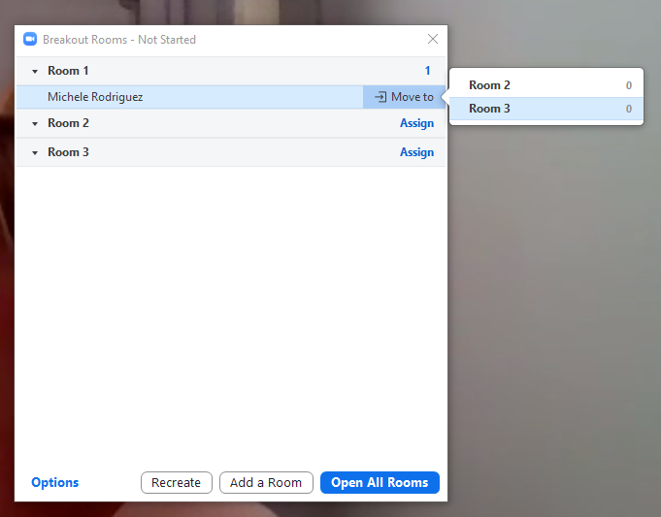

* Click the button to open all rooms
* Participants will disappear from the zoom grid view as they join their rooms, watch for all participants to join
* Keep the breakout room box open, it will also tell you who has not joined **and this is where you will move the presenter and other moderators to another room**
  + *To move the presentor or a moderator to a room, hover over their name, select* ***move to, then the room you want to move them to.***
* 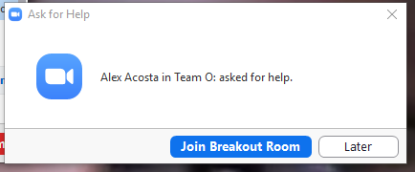If a breakout room needs help you will see the following message. Join the room, assist as you can and click leave in the lower right corner to return to the main session.

*Remember the presenter and other moderator(s) will be returning to the main room to be put into other rooms. You may need to trouble shoot a bit, return the main room and then go back to that breakout room if it’s an extended issue.*

* You can force the rooms closed if you are running behind and need to make up for lost time. Once you click the button to close the rooms you will see a 60 second countdown

AS PRESENTERS AND MODERATORS VISIT CHAT ROOMS

* If you don’t see a pop-up to *accept* an invitation to join a breakout room look at your Zoom toolbar, you should now see a breakout room icon. Click that to view the pop-up.
* Pop-into the breakout room
  + Verify they have chat open to see the scenario & list of interviewees
  + Verify they have someone who will be writing and reporting back in the main session

**Moderator 2 / Co-Host**

* Everyone will return with their **mike on**. Use the participants window to mute everyone except the presenter

1. Presenter will ask participants to unmute and provide insight into what their group shared in the breakout

room & highlight that, despite our diverse jobs our concerns are, all the same.

* First group to volunteer to speak will get 2 tickets for each group member
* Monitor chat
* Make sure you can see the participant screen and watch mikes for those that forget to unmute or mute when they finish speaking

1. Presenter will review the STOP checklist
2. Presenter will cover the *Until Next Time* introduction of Unit 3

**AFTER THE SESSION**

Participate in a quick wrap up to discuss what went good & not so good

Review what the breakout or activity will be in the next session to ensure there is a plan or a plan to create a plan

**Absent Attendee Plan:**

Session is recorded. Presenter will email anyone absent to arrange a time to cover this material before next class

Moderator 1 / Host

* Take any notes that need to be added to the session notes for next time around
* Email the white board screenshot to Jeff
* Keep a copy yourself and plan to moderate unit 5 (week of Nov 1) where you will launch this whiteboard again