REIMBURSING PROCEEDS TO THE COLORADO SCHOOL OF MINES

**OVERVIEW**

CU Boulder Surplus has an agreement with the Colorado School of Mines enabling them to forward their surplus property to us for processing, we disposition assets for them and return proceeds to them for items that sell to the public when the net value is $100 or more. The process is similar to our campus departments wherein month end processing results in review of items sold and preparations for return of proceeds. We cannot return proceeds via a Journal Entry, therefore a check must be requested from the PSC to facilitate payment of proceeds due.

The Office Manager completes month end or auction reporting, prepares an invoice from the Colorado School of Mines (CSM) for proceeds due to them, saves the invoice as a pdf, and forwards invoice to the Administrative Assistant to request a check from the PSC and follow up on receipt. Each fiscal year’s invoice set is saved the CSM Admin Files folder located here.

When multiple sales types require a proceeds payment in a given month wait until the first check has been cut to request the second check. As we approach fiscal year end in June discuss the need for multiple checks and timing with your supervisor.

*Note: PSC has a tendency to group individual requests onto one payment if the vendor is the same. This can cause confusion when communicating with the CSM. In the event we need to return proceeds for more than one sales type during a given month best practice is to wait until the first check has been cut and sent out before requesting a check for the other sales type. Once we can see the check has been cut for the first request best practice is to wait a day after the date of the first check, then send the 2nd request. When needing to follow this procedure request the largest check first. If you run into this in June discuss with your supervisor as we will want all proceeds due to be paid out before the end of the fiscal year on June 30th!*

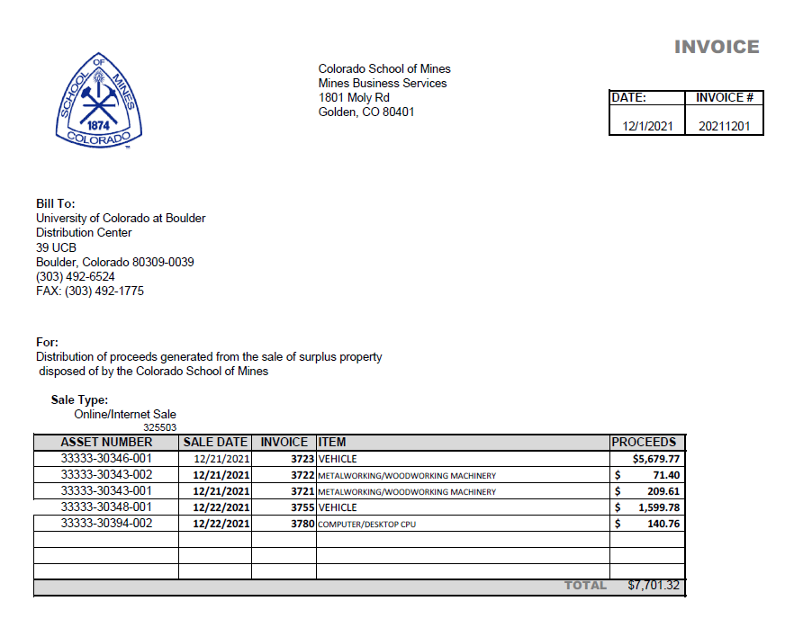

**STEP ONE:**

**REQUEST A CHECK USING THE PAYMENT AUTHORIZAITON FORM IN THE CU MARKETPLACE**

1. Open the link or navigate to the folder to locate the invoice for the School of Mines

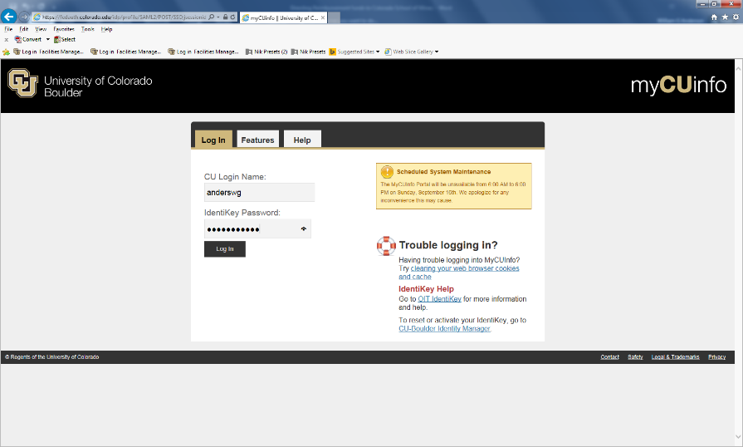

1. Request the check in the CU Marketplace
   1. 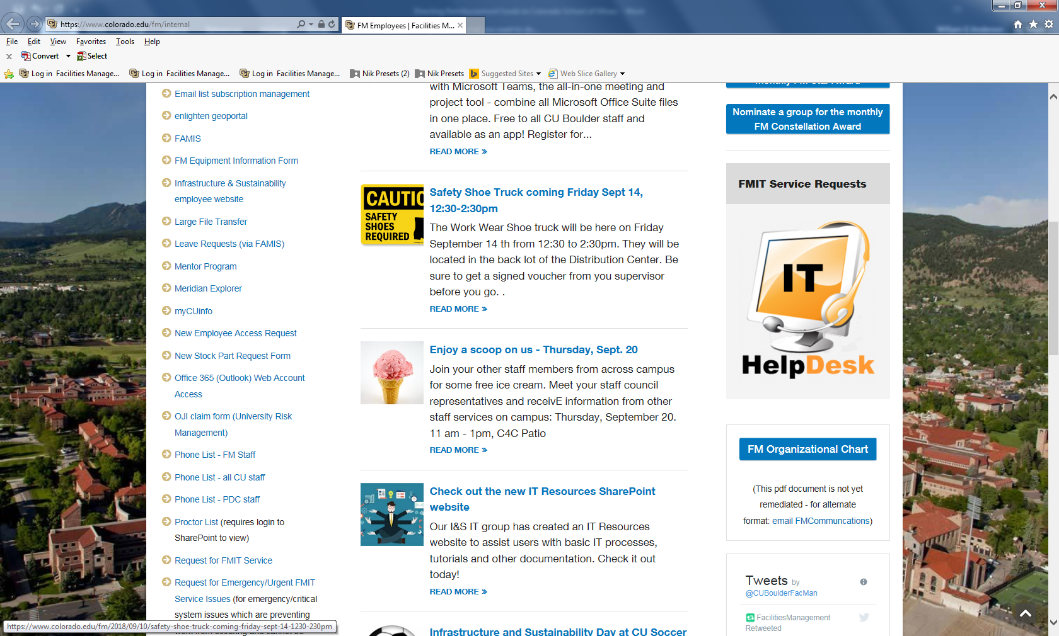Log into [**my CU info**](https://mycuinfo.colorado.edu) using your identikey/password
   2. Open the **Marketplace**  link

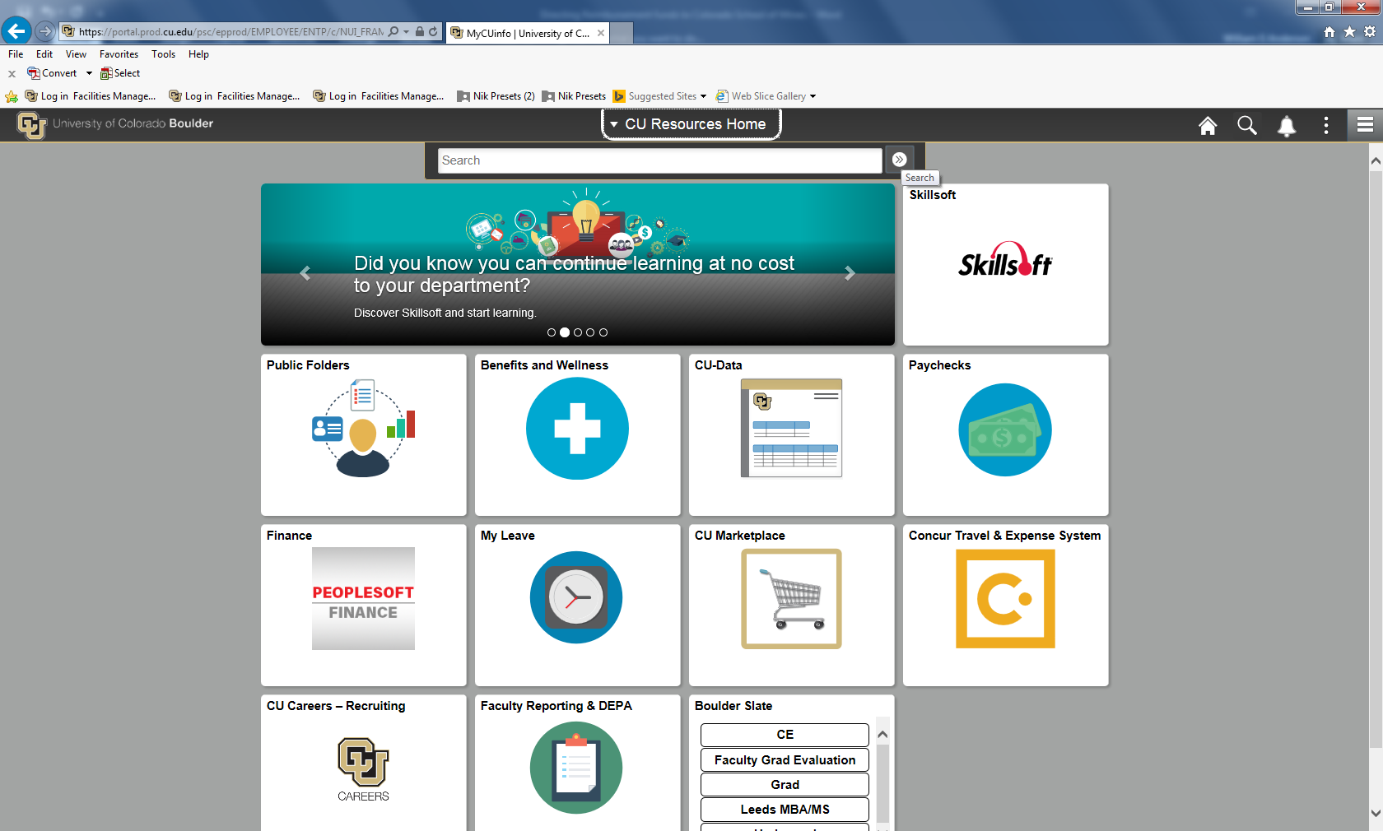

* 1. In the ***Shop*** section, locate the ***Forms*** link

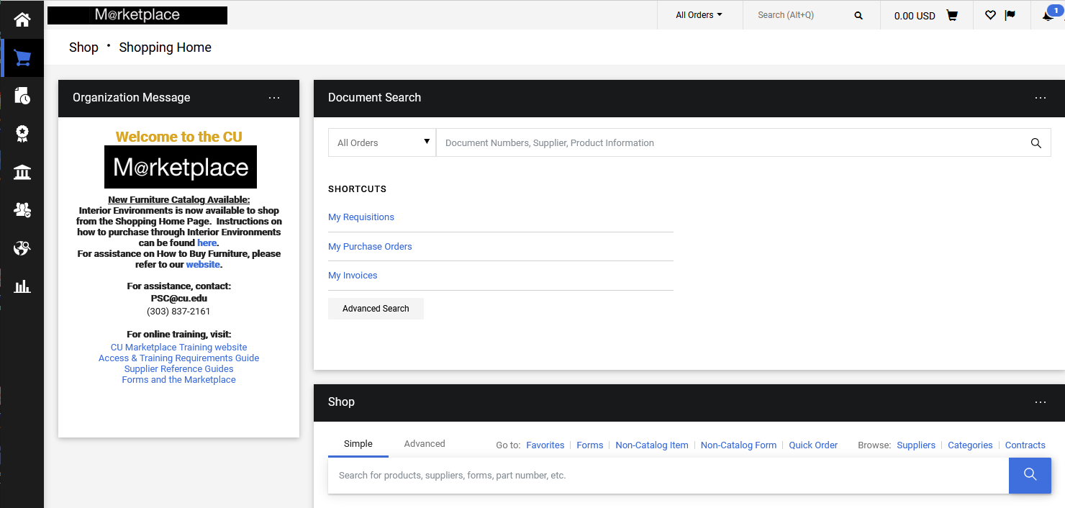

* 1. Click the form name to select the***Payment Voucher Form***link

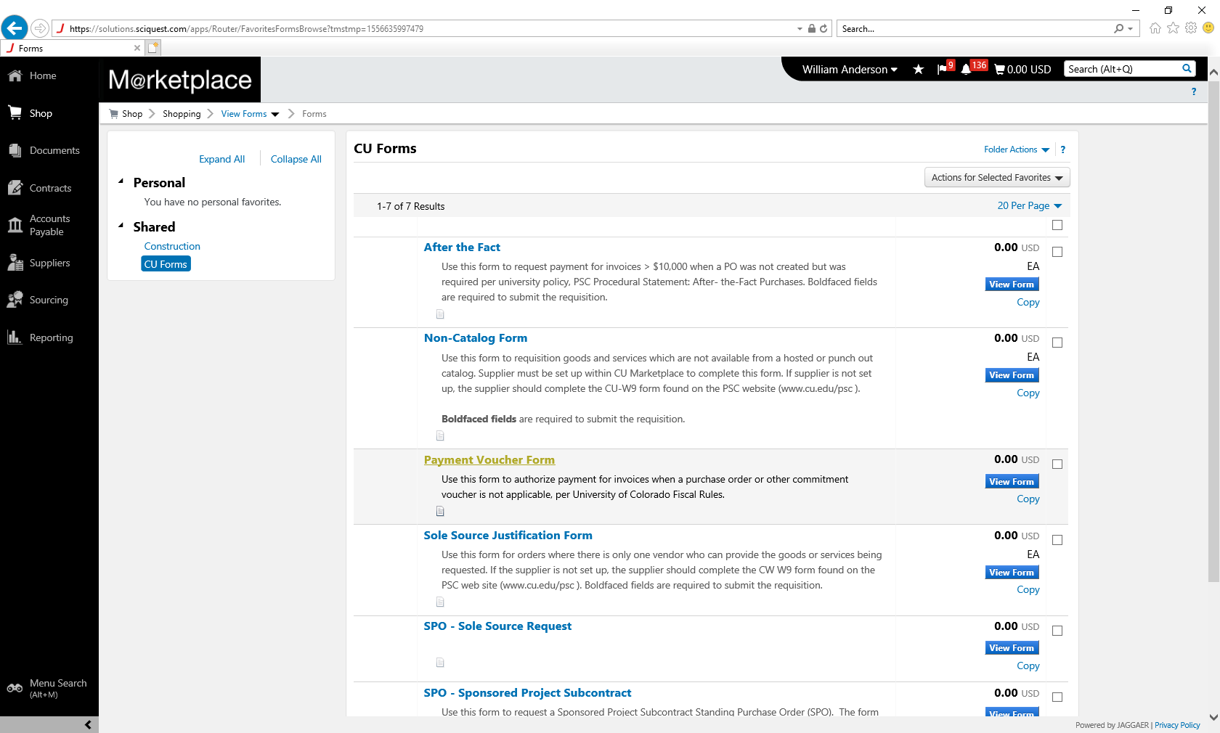

* 1. Complete the *Payment Voucher Form* using the information below and the invoice
* **Supplier:** Colorado School Of Mines
  + It should provide a supplier list after you begin typing, select the CSM
  + If not use the search button to search for them

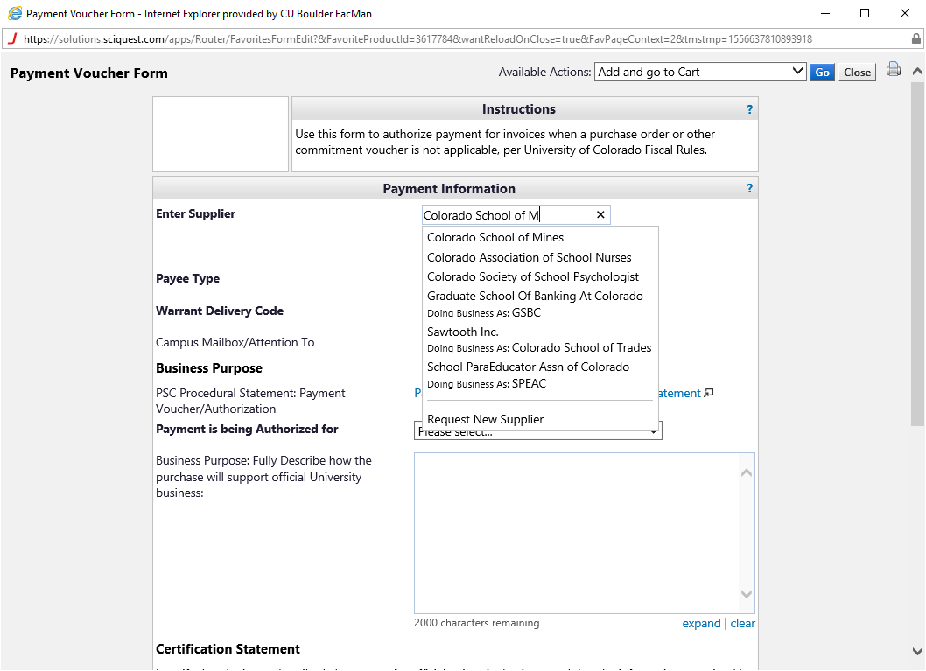

* **Fulfillment Address**: default is the Office of Financial Aid, click the link to select a different fulfillment center and change the address to *Mines Business Services*
  + The pop up will list a number of locations, select location 186 & verify selection

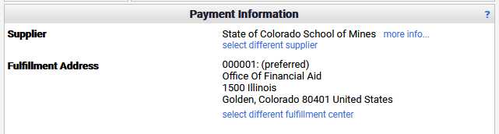 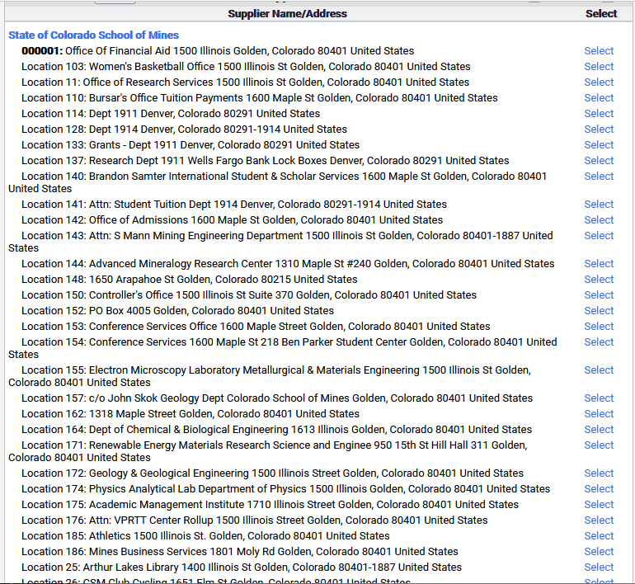

* **Payee Type:** Non-Employee(Individual or Entity)
  + Email should show [csands@mines.edu](mailto:csands@mines.edu)
  + *If Chris should ever leave his position there we will need to update this!*
* **Warrant Delivery Code:** Regular Mail
  + **Attention To:** Chris Sands
* **Payment Authorized for**: State of CO/Other Higher Ed Institution Interagency Agreements
* **Business Purpose:**

*To reimburse the Colorado School of Mines for equipment sold through Surplus Property Sales at CU Boulder based on an MOU agreement for sales transactions between CU Boulder and the Colorado School of Mines.*

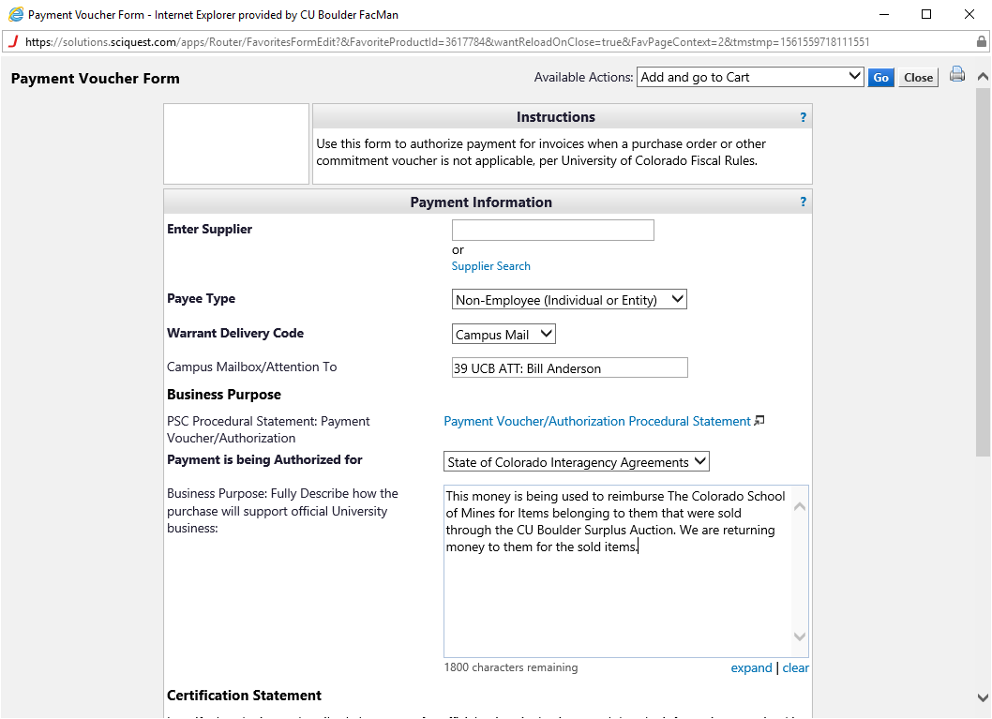

Use the information from the invoice received from your supervisor to complete the next fields on the form.

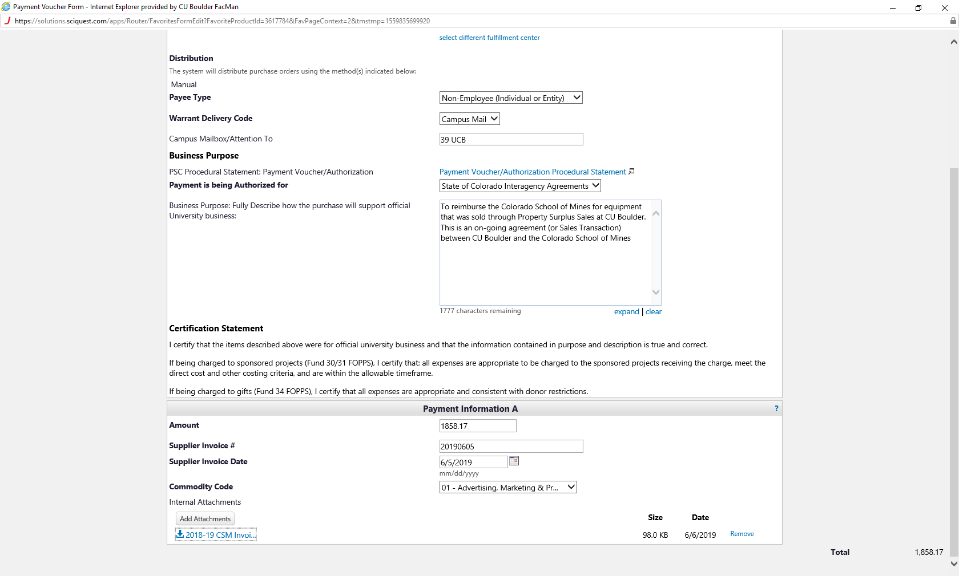

* Amount
* Invoice Number
* Invoice Date
* Commodity Code is always : *01-Advertising, Marketing & …..*
* **Attach the copy of the invoice**
* Scroll to the top of the form, verify your *Available* Action = ‘Add and go to Cart’, click GO to submit the form to the Marketplace

You will see a preview of your Payment Voucher Form. Verify your total in the details box on the right, then click the box to add the speed type and account numbers

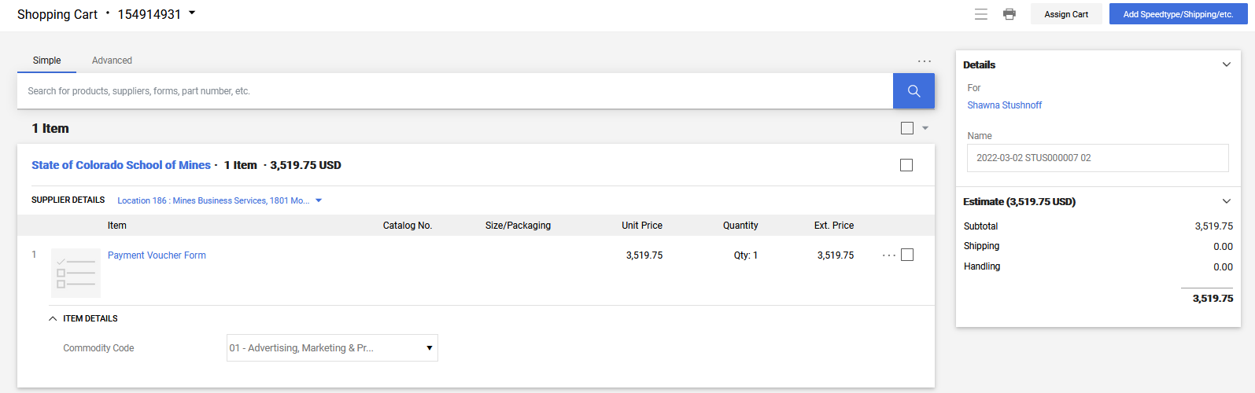

You are within the requisition. The missing speed type and account numbers are noted in the Accounting Codes box in the center of the page. Click either of the blue links in the *Draft* box on the right to access and update the fields.

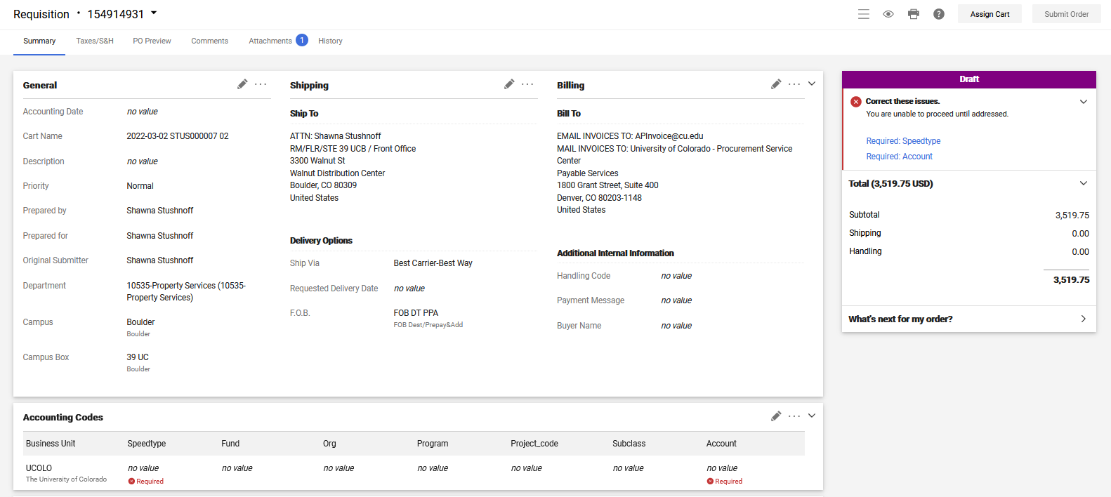

The *speedtype* will always be: 12920407

The *account number* will change based on the type of sale

**325503 for Internet Sale 325501 for Direct Sale 325504 for Auction Sale**

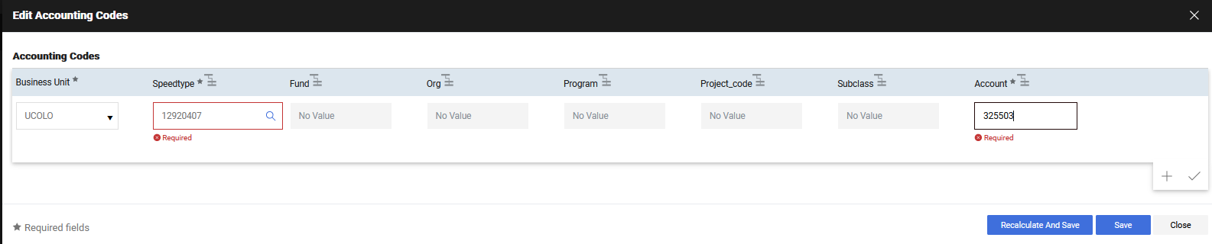

Enter the values, then click *Recalculate & Save*

The draft box no longer shows corrections need to be made, you can submit the order using the blue button in

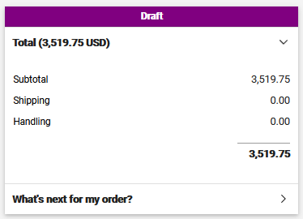 the upper right of the screen.

Use the Snipping Tool to snip a copy of the requisition, then paste it into an email to the director

Check request to return proceeds to the Colorado School of Mines for Internet Sales in February 2022

I’ve just requested a check for the Colorado School of Mines for internet sales proceeds in February. Please be on the lookout for it!

Click on the Requisition number to open the requisition

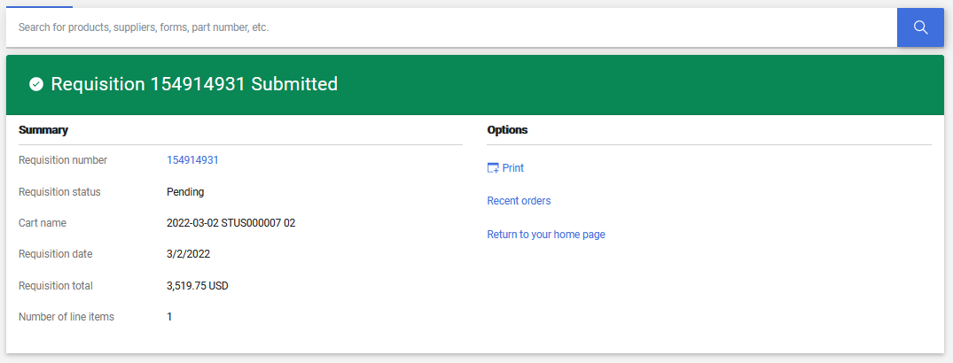

To ensure others are able to easily follow up on the check request in your absence print the requisition as a .pdf and save it to the appropriate sales folder (Internet, Direct, Auction sale folder).

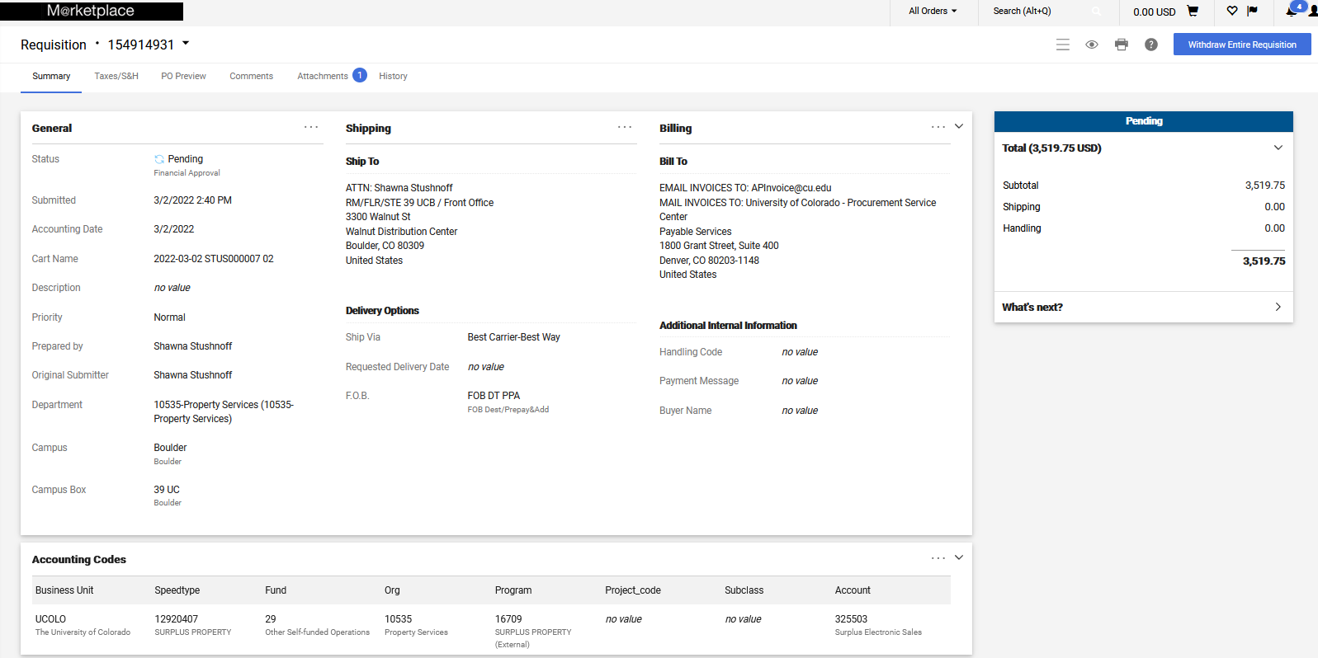

* Click the printer icon in the upper right of the screen, you will be routed to a print view of the form

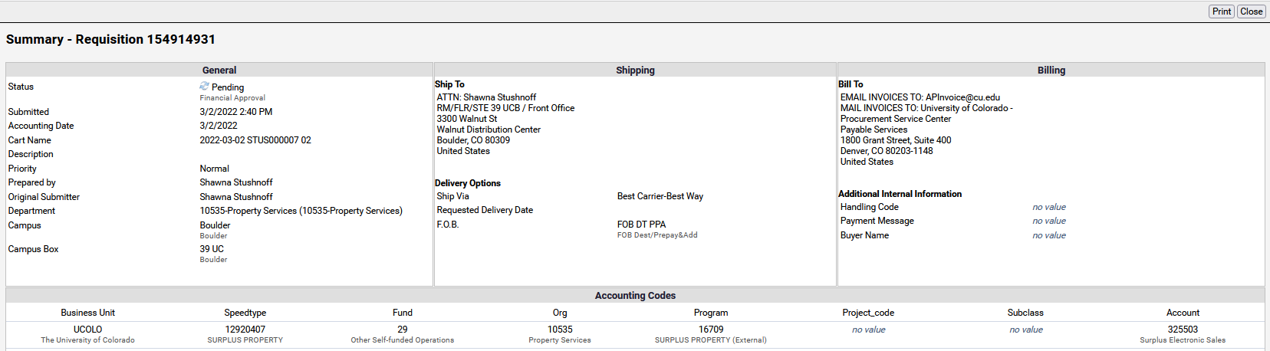

* Click the *print* box in the upper right

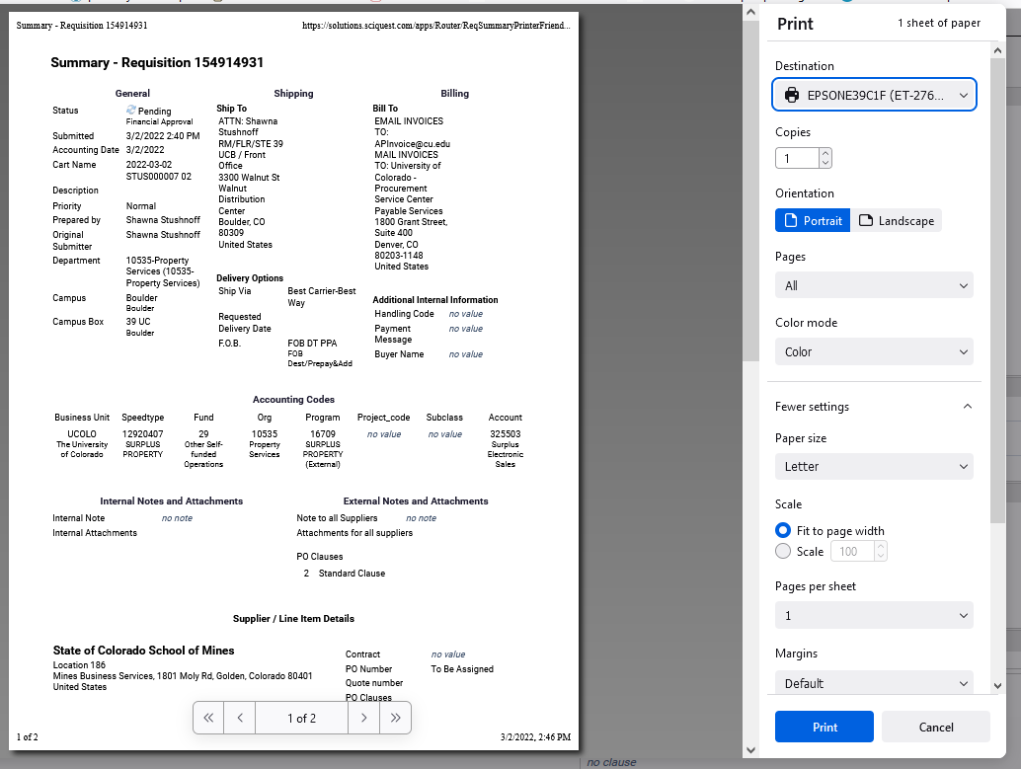

* At the print pop-up change the printer type to .pdf and save the file

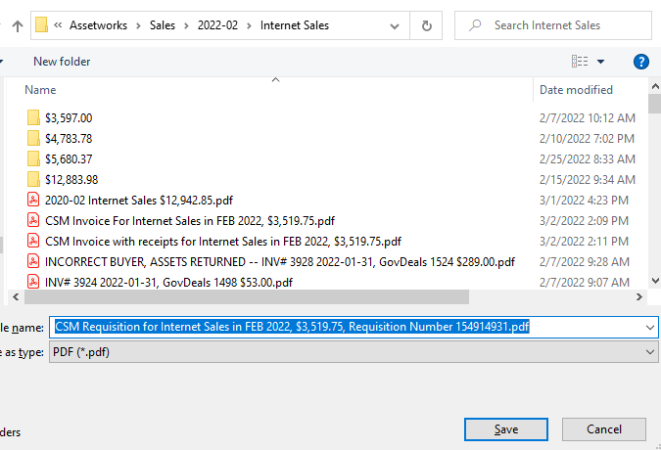

* Click the *CSM Invoice* file name and change “invoice” to “requisition, append the requisition number to the end of the file name.

Add a calendar reminder to check the requisition tomorrow to verify the Director has approved it and there is a PO number.

Email the director to alert them that there is a pending requisition for a proceeds check for the School of Mines.

**STEP TWO:**

**FOLOW UP ON YOUR REQUEST**

To see the status of a request search for your requisitions, click on the requisition number.

1. Log into my CU info, go to the Marketplace and search for your requisition.
2. To view details, click on the requisition number

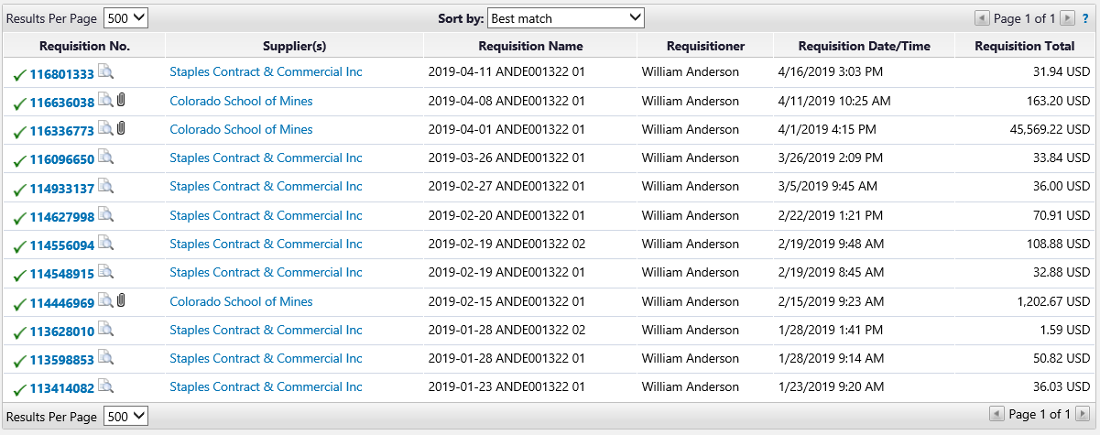

1. 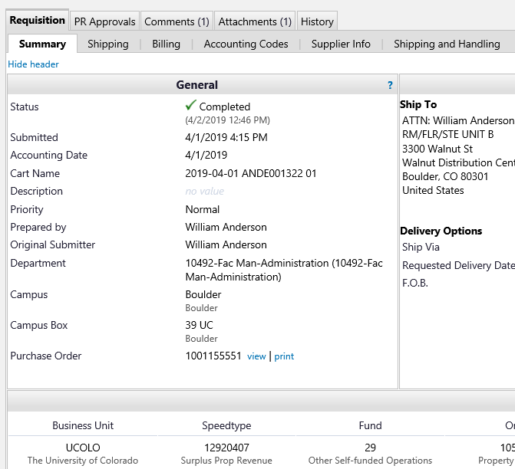Scroll down and locate the PO number on the left side, this is the number you will write on the Invoice when you email it to [apinvoice@colorado.edu](mailto:apinvoice@colorado.edu) in the next step.

**STEP THREE:**

If the check has not been cut add another calendar reminder to follow up on the check. Once the check has been cut you will email the School of Mines to alert them to watch for it.

**STEP FOUR:**

**FOLLOWING UP ON THE REQUESTED CHECK**

1. Go to your requisition page, click on the requisition number
2. Scroll down and locate the PO number on the left side, click to view



1. Review this page

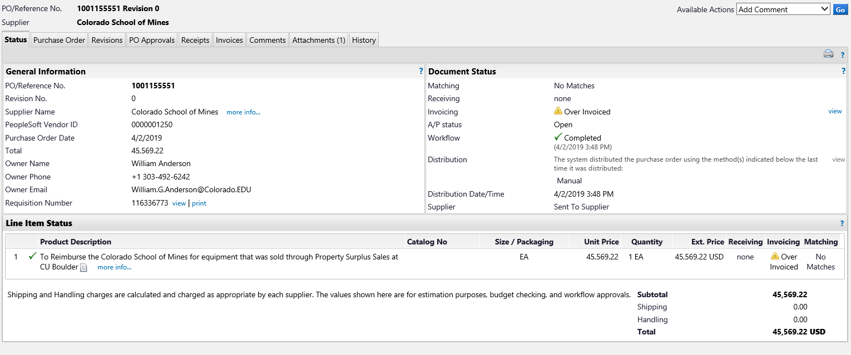

* Invoicing should show matched
  + If you see “over invoices” you may have completed the wrong form. This is used when processing a payment against an existing PO and you don’t have enough money already set aside in the PO to cover the payment request. We don’t process through a PO! Review your saved requisition request to ensure you completed a Payment Authorization Form
* The total should match the invoice you sent over to them
* Click the *Invoices* tab to see details on processing of your requested check.

1. Review the Invoice tab:

* You should see the CU Assigned invoice number (the S number, or voucher number) in the first column.
* Check the dollar amount of each invoice against the total amount of the requisition, see green arrow above. These amounts should match. If not you may have two invoices included in one check and we will need to fix that as we cannot pay both auction sales & internet sales, or direct sales & internet sales, etc. from the same account, we need separate checks! See *Reference* area at the bottom for procedures and language to fix this.
* Look at the *Payment Status*  column to determine if the check has been processed.
  + Unless you requested special treatment to pay earlier requests are processed 30 days after they are received, net 30. Look at the Invoice Date vs the Due Date, has it been 30 days?
* Click the Invoice Number to view details

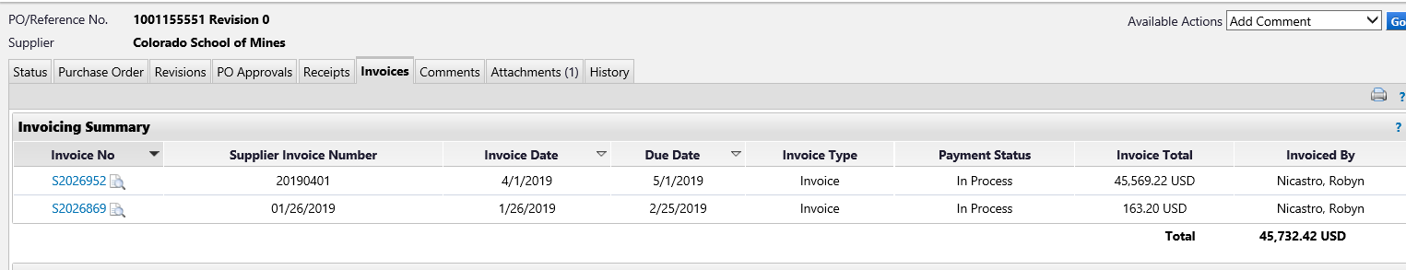

**STEP FIVE:**

**CHECK RECEVIED – FORWARDING TO SCHOOL OF MINES**

Once the check is received, append the check to the file with the requisition number

1. Open the file with the invoice and requisition number
2. Place the check in the scanner and scan it, make sure it adds itself to the bottom of the file, if not use the *Combine Files* option in Adobe to combine the files so the check copy is at the bottom.

Prepare the check to email to the School of Mines

Retrieve the Invoice you wrote the PO number on the top of - from your *pending work file* and include it in an envelope with the check! Address envelope as noted below.

**CO School of Mines**

**Business Services**

**1801 Moly Rd.**

**Golden, CO 80401**

Add a sticky with the following speed type to the envelope and drop off at Mail & Package Services for mailing

Speed Type for Postage: 11016222

Email the School of Mines to advise them of the pending check, attach the invoice.

To: [csands@mines.edu](mailto:csands@mines.edu), [poole@mines.edu](mailto:poole@mines.edu) Christian Sands & Lauren Poole

Cc: yourself, Shawna, Denise Flack

Please find attached an invoice representing a payment due to the School of Mines for surplus property sold here through CU Boulder Surplus Property. We are mailing the check out today, please let us know when you receive it, or if you do not receive it within a week.

REIMBURSING TO SCHOOL OF MINES – QUICK REFERENCE

**OVERVIEW**

CU Boulder Surplus has an agreement with the Colorado School of Mines enabling them to forward their surplus property to us for processing, we disposition assets for them and return proceeds to them for items that sell to the public when the net value is $100 or more. The process is similar to our campus departments wherein month end processing results in review of items sold and preparations for return of proceeds. We cannot return proceeds via a Journal Entry, therefore a check must be requested from the PSC to facilitate payment of proceeds due.

The Office Manager completes month end or auction reporting, prepares an invoice from the Colorado School of Mines (CSM) for proceeds due to them, saves the invoice as a pdf, and forwards invoice to the Administrative Assistant to request a check from the PSC and follow up on receipt. Each fiscal year’s invoice set is saved the CSM Admin Files folder located here.

When multiple sales types require a proceeds payment in a given month wait until the first check has been cut to request the second check. As we approach fiscal year end in June discuss the need for multiple checks and timing with your supervisor.

**STEP BY STEP**

1. Open the link or navigate to the folder to locate the invoice for the School of Mines
2. Request the check in the CU Marketplace
3. Email the director to alert them to a forthcoming approval request from the PSC to authorize the Payment for the Mines check
4. Set calendar reminders to verify issuance of PO
5. Notify CSM of forthcoming check via email and attach a copy of the invoice
6. Verify issuance of the check
7. Follow up with CSM if they have not advised of receipt of the check within a couple of weeks.