Installing & Using the Zoom Phone App

The steps below will highlight the process you’ll want to follow to install the Zoom App on your CU phone. These screenshots are from iPhone, however the process will be similar on other phones.

1. Start by locating the App icon on your phone and tapping it.
   1. 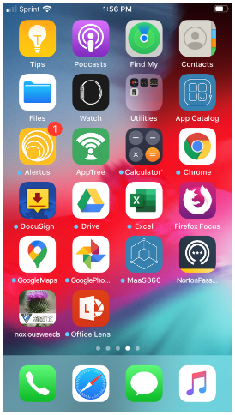If you are using a phone issued to you by CU Facilities Management look in the App Catalog to locate the icon.

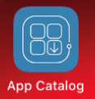

* 1. If you are on a personal phone the App icon will look like one of the following



Apple/iPhone Android

1. To search for the app type **Zoom** into your search area and then tap the search button to search for the app

Looking for the blue “Zoom” icon with the camera that says “Zoom Cloud Meetings”

CU Phone iPhone

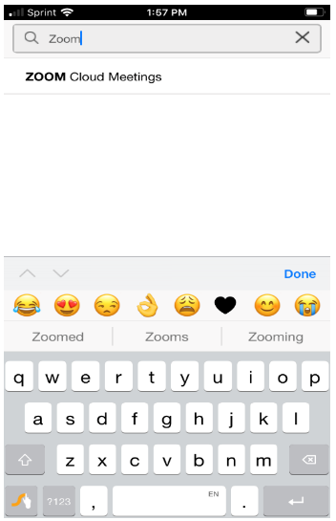

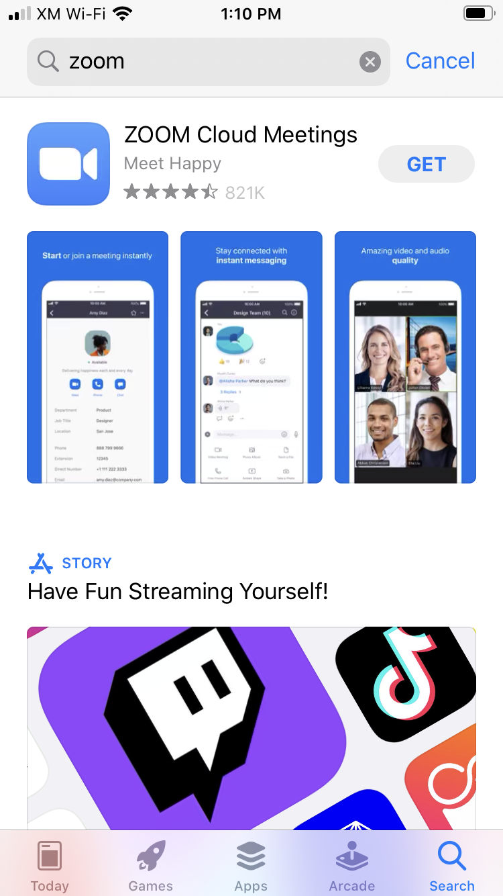

1. Look for and click the **“Get”, “Install”, “Cloud with arrow”** or other similar button to download the App to your phone. Once installed you will see an **Installed** button if you have a CU Phone

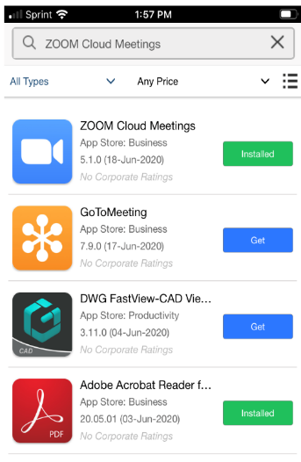****

Tap the Install button if you see one, you should see an install progress bar

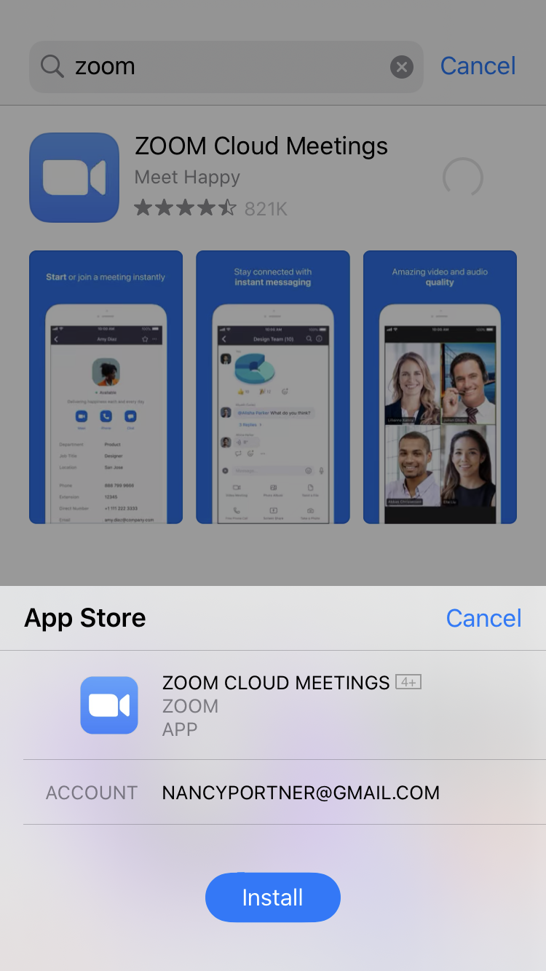

1. Once the application has down loaded you should see an Open button, when you tap the button to open Zoom look for the logon screen

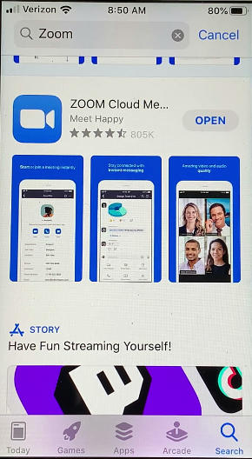

1. Once the Zoom App has been installed on your phone you should be able to access it at any time by clicking the Zoom icon on your phone’s screen.
2. There are three options on the Zoom home screen, follow steps in a, b, or c below then go to step 7
   1. Join a meeting using the meeting ID
   2. Sign into your CU Boulder Zoom account, everyone has one!
   3. Sign Up for Zoom if you’d like to have a personal account as well

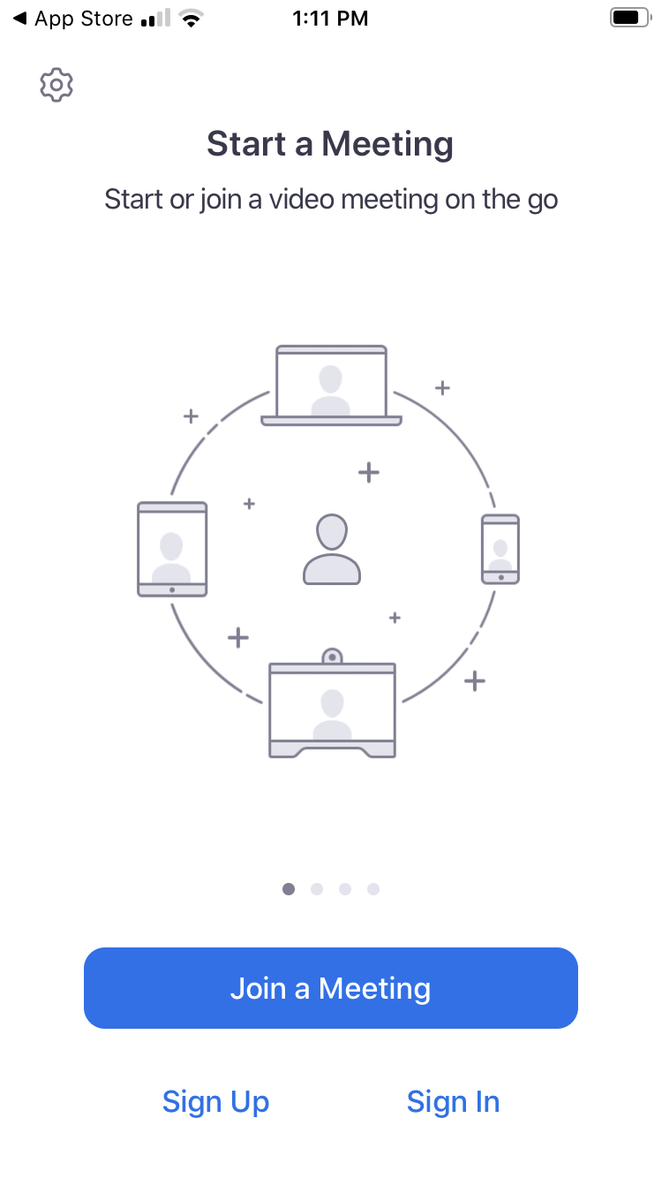

1. Joining a meeting using the meeting id

* Click the Join a Meeting option, see screenshot above
* Type in the meeting ID
* You can adjust your display name
* Click the blue Join button



b. Signing in with your CU Boulder Account

* Click the Sign In option
* Enter the company domain = cuboulder
* Click the blue Go button



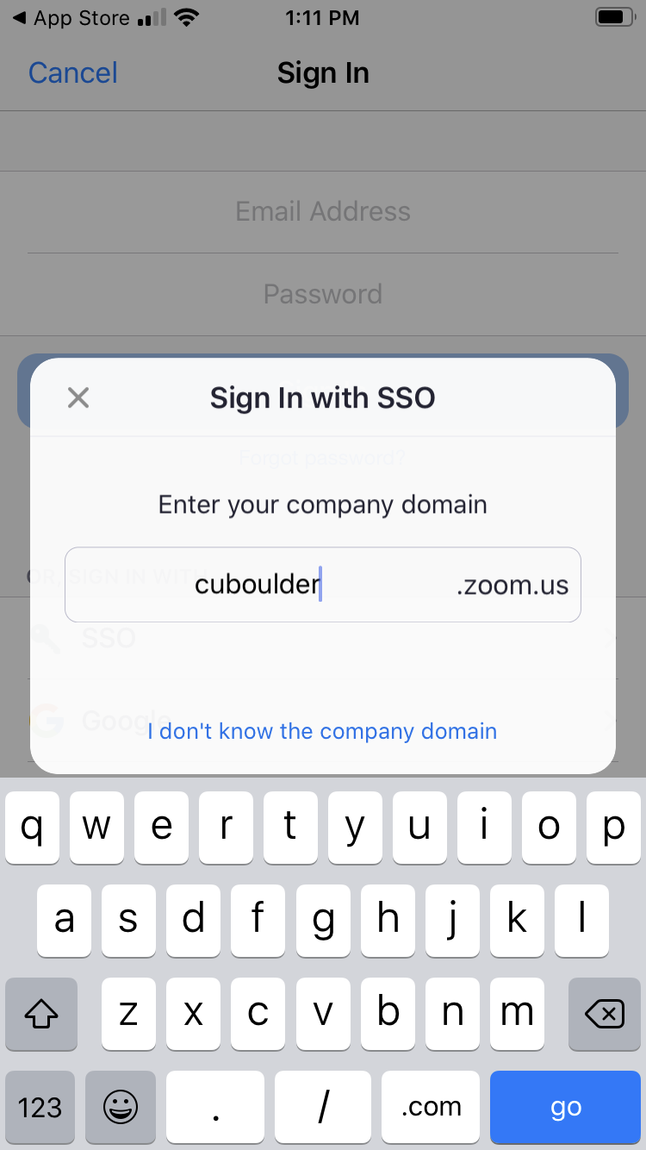

Sign in with your identikey and password

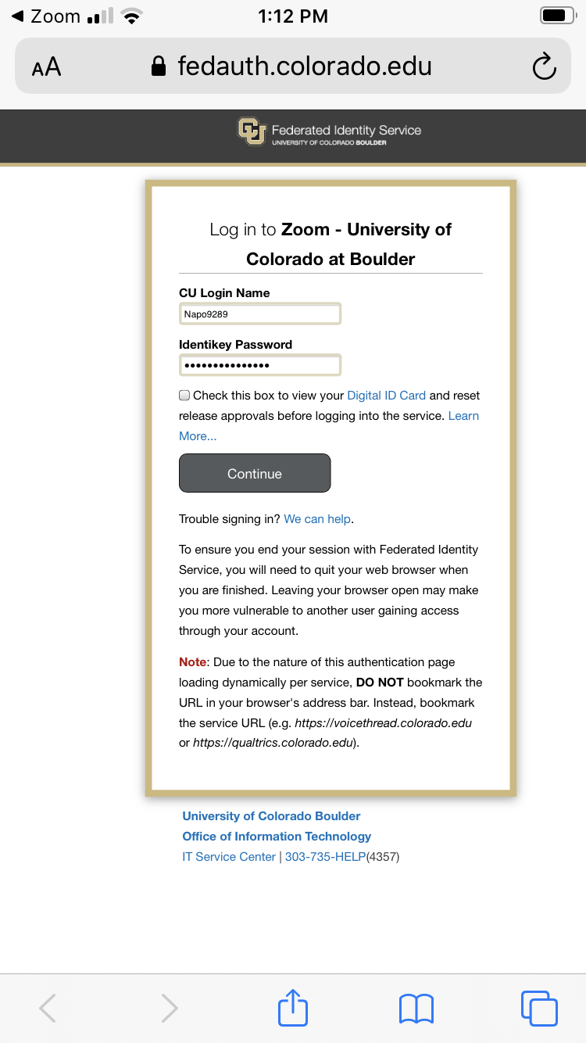

* + 1. Use the Sign Up option if you’d like to create a personal Zoom account to host meetings



1. When logging into Zoom or signing onto a meeting you may need to confirm whether you would like Zoom to access your calendar and camera





1. Select whether you’d like to use your phone’s internet for audio or dial in on a telephone



1. A list of Zoom *meeting* options is below. If you are on a *webinar* hosted on Zoom your options may look a little different as some functions are disabled on a webinar.

**Zoom Down Arrow**

Clicking this arrow opens a screen with meeting details and information

**Leave**

Tap this button to leave the meeting

**Camera & Microphone**

Tap the icons in the lower left to turn on/off

If you have a photo attached to your Zoom profile and you sign into your profile before joining the meeting your photo will show up in the middle of the screen when your camera is off.

**Screenshare**

The green square with the arrow is the icon to share your screen, you may

or may not have access to this function based on the meeting settings.

**“More” icon**

The three dots are a universal icon to access “more” options. These options will change based on whether you are hosting or attending the meeting. Highlights are:

* Applause and thumbs up icons
* Access to the chat function
* Virtual backgrounds

**Participants**

Clicking the participants icon will show you who has joined the meeting and give you access to some other functions as well. When you activate an option an icon shows up in the upper right of your screen

* Sending a communication to the presenter if they are going to slow or fast
* Raising your hand – *notice the screenshot on the below has a raised hand*
* Responding Yes or No

Use the Close button in the upper left to return to the main screen

