**Carl the Cameleon**

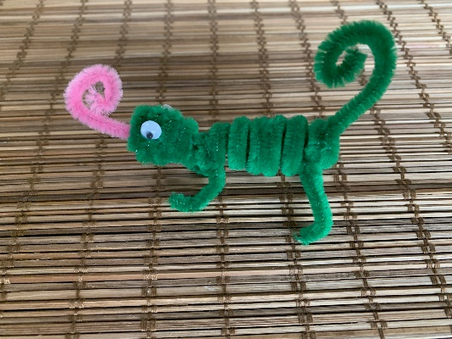Carl was the second creation in my pipe cleaner animal collection, and actually easier to make than Foxy Loxy I think. This little fellow wasn’t part of a class or an assignment, but rather born of a quest to find fun things to put in the larger cache containers as my husband and I enjoy our newest hobby of geocaching around home and other places we go. We’ve become rather attached to this activity that can take as little or as much time as you like and probably the best part is - it takes you to places and information that you might never have noticed. Believe it or not, some of them right in your own neck of the woods and right under your nose! If you’re not familiar check out [www.geocaching.com](http://www.geocaching.com)

So here is critter number two and if you’re a geocacher you may find a few different animals in my collection as you step onto a trail I have wandered down before you. If so, your critter bag should have most, if not all, of the supplies you need. Hopefully creating these little creatures becomes a fun pastime that anyone can entertain themselves with. If you come up with your own critter send me a photo and instructions and I’ll add it to the cache collection that I leave in the wake of my travels.

Either follow the instructions in the video below, or if you have an internet connection you may find it easier to use the video on my website to create your Carl. Video Link:

**Supplies:**

1. Three green pipe cleaners
   1. One folded in half around your finger
   2. The second either straight or lightly rolled in circles to fit in the cache bag
   3. The third cut into four equal pieces, you’ll only use two of these pieces for this project
2. One pink pipe cleaner cut into four equal pieces, you’ll only use one of the pieces for this project
3. Two eyeballs
4. Glue
5. Pencil or pen

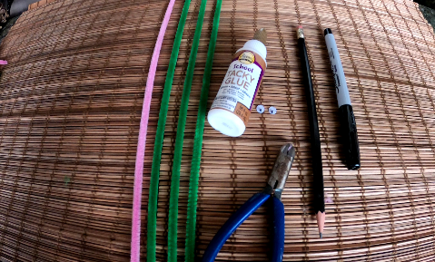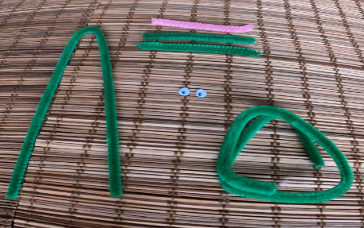

**Instructions**

1. 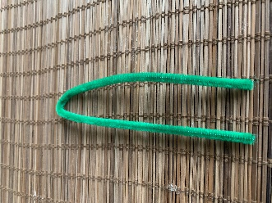Take one green pipe cleaner, match the ends up and hold between a finger and thumb, then place your other finger in the middle and slide it up to the other end to divide the pipe cleaner in half.
2. 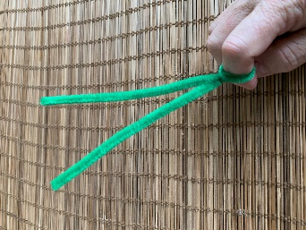Keep your finger in place and twist the pipe cleaner twice to form the small round circle that will become the chameleon’s head.
3. Use one straight end to wrap around the circle to form the chameleon’s head.

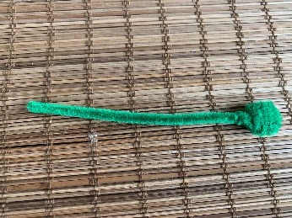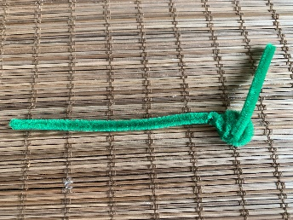

1. Wrap the second green pipe cleaner around a pencil or a marker to make the body. If you are working with a geocache kit this will be the one that has been wound into circles so it fits in the bag! Remove the coil from the marker, you can press the coils together if you feel like they are too far apart. You may wish to make the ends tighter than the middle to give the body a bit more shape. Slide the coil onto the straight end of the body/head piece you finished in the last step.

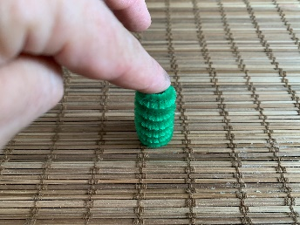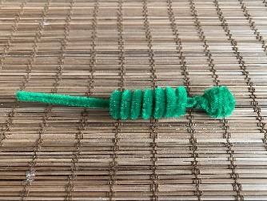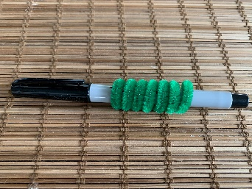

1. Wrap the end of the pipe cleaner around a pencil or pen to make the tail. This also holds the body coil on the pip e cleaner. Twist the head so the head and tail line up on the same plane (the same direction)

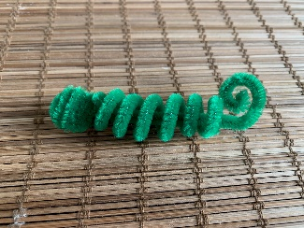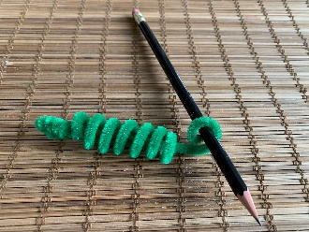

1. 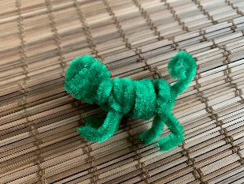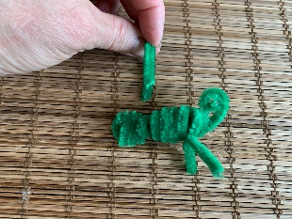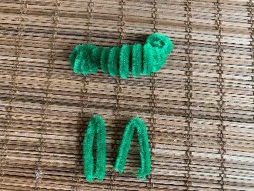The two short pieces are the legs, slip them over the body coils and twist to secure. Place one near the head and one near the tail.
2. Roll a small portion of the pink pipe cleaner to create the tongue and slide it in between the layers of the head. Finally glue on your eyeballs and you’re all set!

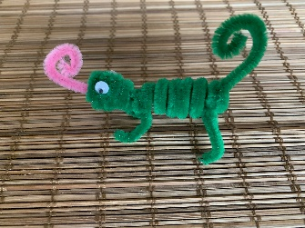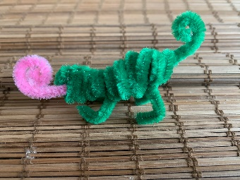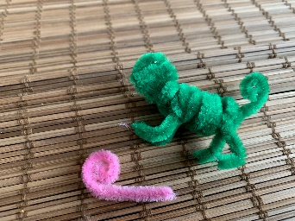

**Happy Creating!**

*Stoosh 1* c/o Shawna’s Studio88